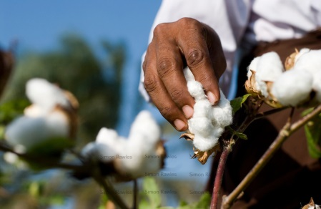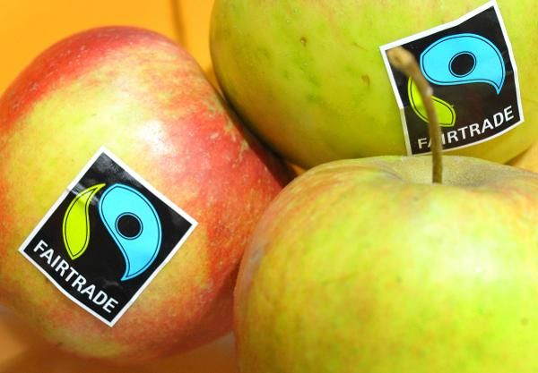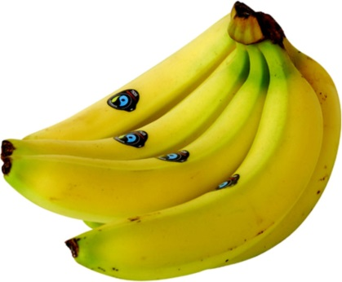

India, china, brazil, Pakistan, turkey

Ghana, Africa and Asia

India or China

China or India

China

Brazil, Vietnam, Colombia and Indonesia. Latin America, Asia Oceania and Africa.

Ecuador, the Dominican Republic, Colombia, St Lucia, St Vincent, Dominica, Grenada, Ghana, Costa Rica, Panama, Peru and Brazil.