**Case Study: Edward Snowden**

In April 2013, Guardian journalisf Glen Greenwald and Academy Award-winning documentary film director and producer Laura Poitras met in the Marriott Hotel in New York to discuss an initial contact with an anonymous "whistle-blower". Seated in the hotel restaurant, Laura Poitras asked Glenn to either remove the battery from his cell phone or leave it in the hotel room. "It sounds paranoid," she said, "but the government has the capability to activate cell phones and laptops remotely as eavesdropping devices. Turning off the phone or laptop does not defeat the capability; only removing the battery does."

The anonymous source had refused to email any details of what material he had to offer until Glenn installed PGP on his computer. PGP, which stands for "Pretty Good Privacy" is a sophisticated tool to prevent online communications from being hacked. The encryption codes are so lengthy and random that it would take years to decrypt a communication. But it was complicated to install and it took Glenn several months to get round to it, before he was eventually talked through the process online by his anonymous contact. Only then did he receive information from his source about a program called PRISM, which allowed America's National Security Agency (NSA) to collect private communications from the world's largest Internet companies, including Facebook, Google, Yahoo, Microsoft, Apple, YouTube, AOL and Skype.

The first document that Glenn opened was a training manual to teach analysts about the new surveillance capabilities. It told analysts how they could query, for example, particular email addresses or telephone numbers and what data they would receive in response.

What did the source hope to achieve by exposing the secret surveillance practices of the NSA?

*"I want to spark* a *worldwide debate about privacy, Internet freedom, and the dangers* of *state surveillance," he stated. "I'm not afraid* of *what will happen to* me. *I've accepted that my life will be over from my doing this. I'm at peace with that. I know it's the .right thing to do."*

The next step was for Glenn and Laura to travel to Hong Kong to meet the whistleblower _ Edward

Snowden, a 29-year-old who had worked since 2005 as a technical expert for the CIA, NSA and its sub-contractors, making around $200,000 in salary and bonuses. He had travelled to Hong Kong in May, staying in a hotel under his own name, figuring he was safer there than staying in the US when news of the leaked documents broke.

*"I watched NSA tracking people's Internet activities* as *they typed. I became aware* of *just how invasive*

*US surveillance capabilities had become. I realised the true breadth* of *this system. And almost nobody knew it was happening.*

*"For many kids, the Internet is* a *means* of *self-actualisation. It allows them to explore who they are and who they want to be, but that works only if we're able to be private and anonymous, to make mistakes without them following us. I worry that mine will be the last generation to enjoy that freedom. I do not want to live in* a *world where* we *have no privacy and no freedom, where the unique value* of *the Internet is snuffed out. "*

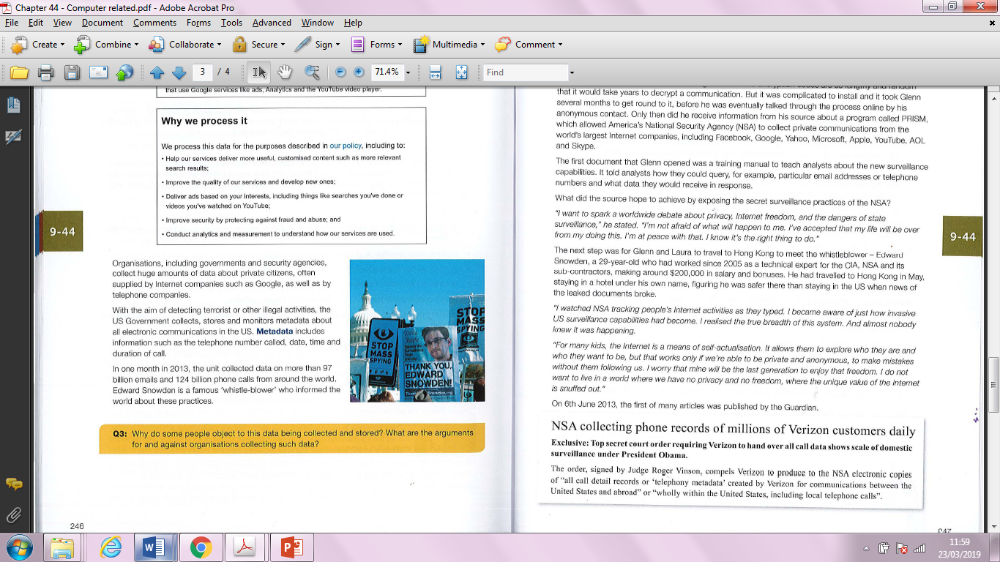On 6th June 2013, the first of many articles was published by the Guardian.

As journalist Glenn Greenwald painstakingly sifted through the mountain of information provided by

Snowden, he was shocked at the extent of the American surveillance operation, It included the NSA's tapping of Internet servers, satellites, underwater fibre-optic cables, local and foreign telephone systems and personal computers, A list of individuals targeted for particularly invasive forms of spying included terrorist and criminal suspects, democratically elected leaders of many countries in Europe including France and Germany, and ordinary American citizens, The documents leaked by Snowden revealed that the literal aim of the US Government was to collect, store, monitor and analyse metadata about all electronic communications by everybody in the world,