|  |  |  |  |  |
| --- | --- | --- | --- | --- |
| **1.3 Exchanging data** | | | | |
| Topic Area | Sub Topic | How I feel | | |
|  | | Red | Amber | Green |
| 1.3.1 Compression, Encryption and Hashing | Lossy vs Lossless compression. |  |  |  |
| Your notes | | |
| 1.3.1 Compression, Encryption and Hashing | Run length encoding and dictionary coding for lossless compression. |  |  |  |
| Your notes | | |
| 1.3.1 Compression, Encryption and Hashing | Symmetric and asymmetric encryption. |  |  |  |
| Your notes | | |
| 1.3.1 Compression, Encryption and Hashing | Different uses of hashing. |  |  |  |
| Your notes | | |
| 1.2.1 Systems Software | Distributed, embedded, multi-tasking, multi-user and Real Time operating systems. |  |  |  |
| Your notes | | |
| 1.3.2 Databases | Relational database, flat file, primary key, foreign key, secondary key, entity relationship modelling, normalisation and indexing |  |  |  |
| Your notes | | |
| 1.3.2 Databases | Methods of capturing, selecting, managing and exchanging data |  |  |  |
| Your notes | | |
| 1.3.2 Databases | Normalisation to 3NF |  |  |  |
| Your notes | | |
| 1.3.2 Databases | SQL – Interpret and modify. |  |  |  |
| Your notes | | |
| 1.3.2 Databases | Referential integrity |  |  |  |
| Your notes | | |
| 1.3.2 Databases | Transaction processing, ACID (Atomicity, Consistency, Isolation, Durability), record locking and redundancy |  |  |  |
| Your notes | | |
| 1.3.3 Networks | Characteristics of networks and the importance of protocols and standards. |  |  |  |
| Your notes | | |
| 1.3.3 Networks | The internet structure:  • The TCP/IP Stack. • DNS  • Protocol layering. • LANs and WANs. • Packet and circuit switching. |  |  |  |
| Your notes | | |
| 1.3.3 Networks | Network security and threats, use of firewalls, proxies and encryption. |  |  |  |
| Your notes | | |
| 1.3.3 Networks | Network hardware |  |  |  |
| Your notes | | |
| 1.3.3 Networks | Client-server and peer to peer. |  |  |  |
| Your notes | | |
| 1.3.4 Web Technologies | HTML, CSS and JavaScript |  |  |  |
| Your notes | | |
| 1.3.4 Web Technologies | Search engine indexing |  |  |  |
| Your notes | | |
| 1.3.4 Web Technologies | PageRank algorithm |  |  |  |
| Your notes | | |
| 1.3.4 Web Technologies | Server and client side processing. |  |  |  |
| Your notes | | |

Exam Questions

1(a)Explain why compression is considered necessary for images on the web.

_______________________________________________________________

_____________________________________________________________(2)

(b) Explain why lossy compression techniques would not be suitable for use with files containing large bodies of text.

_____________________________________________________________(1)

(c) Suggest a suitable lossless method for compressing text.

_____________________________________________________________(1)

2(a) Explain the difference between lossy and lossless data compression.

_______________________________________________________________

_____________________________________________________________(2)

(b) Run-length encoding (RLE) is a pattern substitution compression algorithm, Data is stored in the format (colour,run),

a. (0,1), (1,5), (0,1),

b. (1,7),

c. (1,1), (0,2), (1,1), (0,2), (1,1),

d. (1,7),

e. (0,1), (1,1), (0,1), (1,1), (0,1), (1,1), (0,1),

f. (0 ,1), (1,1), (0,1), (1,1), (0,1), (1,1), (0,1),

g. (0 , 1) , (1,1), (0,3), (1,1), (0,1)

Reassemble the encoded sequence above to form a 7x7 web icon image in the grid below. (3)

|  |  |  |  |  |  |  |
| --- | --- | --- | --- | --- | --- | --- |
|  |  |  |  |  |  |  |
|  |  |  |  |  |  |  |
|  |  |  |  |  |  |  |
|  |  |  |  |  |  |  |
|  |  |  |  |  |  |  |
|  |  |  |  |  |  |  |
|  |  |  |  |  |  |  |

(c)RLE encoding is a lossless compression method, Give one disadvantage of loss less compression over lossy methods for the compression of images.

_____________________________________________________________(1)

3, (a) State what is meant by symmetric encryption and explain with the aid of an example how it can be implemented.

_______________________________________________________________

_______________________________________________________________

_______________________________________________________________

_____________________________________________________________(4)

(b) (i) Explain what is meant by asymmetric encryption.

_______________________________________________________________

_______________________________________________________________

_______________________________________________________________

_____________________________________________________________(4)

(ii) Explain why this form is more secure than symmetric encryption.

_______________________________________________________________

_____________________________________________________________(2)

4. An estate agent keeps a database of all the properties it has for sale, the owners of the properties, and all the prospective buyers.

Details about the properties for sale, including address, number of bedrooms, type of property, asking price are held in a table called Property.

1. Suggest a suitable primary key for the Property table.

_____________________________________________________________(1)

1. Suggest two attributes in the Property table that may be defined as secondary keys, justifying why each should be defined in this way.

_______________________________________________________________

_______________________________________________________________

_______________________________________________________________

_____________________________________________________________(4)

Data on prospective buyers include name, telephone, address, type of property required, lower and upper limit for price.

Data on vendors include name, address, telephone.

A fourth entity, **Viewing** holds data about all viewings.

1. Suggest three attributes for the entity Viewing.

_______________________________________________________________

_______________________________________________________________

_____________________________________________________________(3)

1. Write entity descriptions for each of the entities Property, Vendor, Buyer and Viewing. In each case, identify any primary and foreign keys.

_______________________________________________________________

_______________________________________________________________

_______________________________________________________________

_______________________________________________________________

_______________________________________________________________

_______________________________________________________________

_____________________________________________________________(8)

1. Draw an entity relationship diagram showing relationships between these four entities.(4)

5. A library plans to set up a database to keep track of its members, books and loans, Entities are defined as follows:

**Member** (MemberID, Surname, FirstName, Address)

**Book** (BookID, ISBN, Title, Author)

**Loan** (MemberID, BooklD, LoanDate, DueDate)

When the book is returned the loan record is deleted.

1. Draw an entity relationship diagram showing the relationships between the entities. (3)

(b) A relational database is created with tables for each of these entities. The key in the Loan table is made up of two fields.

What is the name given to a key that is made up of multiple attributes?

_____________________________________________________________(1)

(c) What is meant by a foreign key? Identify a foreign key in one of the tables.

_______________________________________________________________

_______________________________________________________________

_____________________________________________________________(3)

6. An exam board wants to set up a database to hold data about its courses, exam papers, exam entries, candidates and results, For the purpose of this exercise, assume that each candidate can sit each exam once only. A course may have several exam papers (Comp 1, Comp 2, etc.)

The data to be stored for the candidate are CandidateNumber, FirstName, Surname, DateOfBirth,

The data to be stored for the course are CourselD, Subject, Level.

The data held for each individual exam paper includes CourselD, ExamPaperlD, DateOfExam, Title, TotalMarks, ExamPaperWeighting,

1. State an identifier for the entity ExamPaper.

_____________________________________________________________(1)

1. Draw an entity·relationship diagram showing the relationships between the entities. (3)
2. Write an entity description for a Results entity which will store the exam mark that candidates receive for each exam paper.(2)

_______________________________________________________________

_____________________________________________________________(2)

7(a) Discuss the suitability of flat files and relational databases for use by a family at home and for use in a large mail order company.

The quality of written communication will be assessed in your answer to this question.

_______________________________________________________________

_______________________________________________________________

_______________________________________________________________

_______________________________________________________________

_______________________________________________________________

_______________________________________________________________

_____________________________________________________________(8)

(b) In any relational database, primary and foreign keys are used,

(i) What is a primary key?

_____________________________________________________________(2)

(ii) Explain the use of a primary key as a foreign key,

_______________________________________________________________

_______________________________________________________________

_____________________________________________________________(3)

8. The publisher of several magazines has a relational database in which the details of each magazine are held. One of the tables in the database holds details of all the major articles in each magazine.

1. Write a description for entities **Magazine** and **Article**, showing for each table the primary key, foreign key if applicable, and at least two other attributes, using the format

EntityName (primary key, attribute1, attribute2, attribute3 ... foreign key)

_______________________________________________________________

_______________________________________________________________

_______________________________________________________________

_______________________________________________________________

_______________________________________________________________

_____________________________________________________________(6)

1. Suggest, with a reason, an attribute in either table which it would be useful to define as a secondary index.

_______________________________________________________________

_____________________________________________________________(2)

9. A college department wishes to create a database to hold information about students and the courses they take. The relationship between students and courses is shown in the following entity relationship diagram.

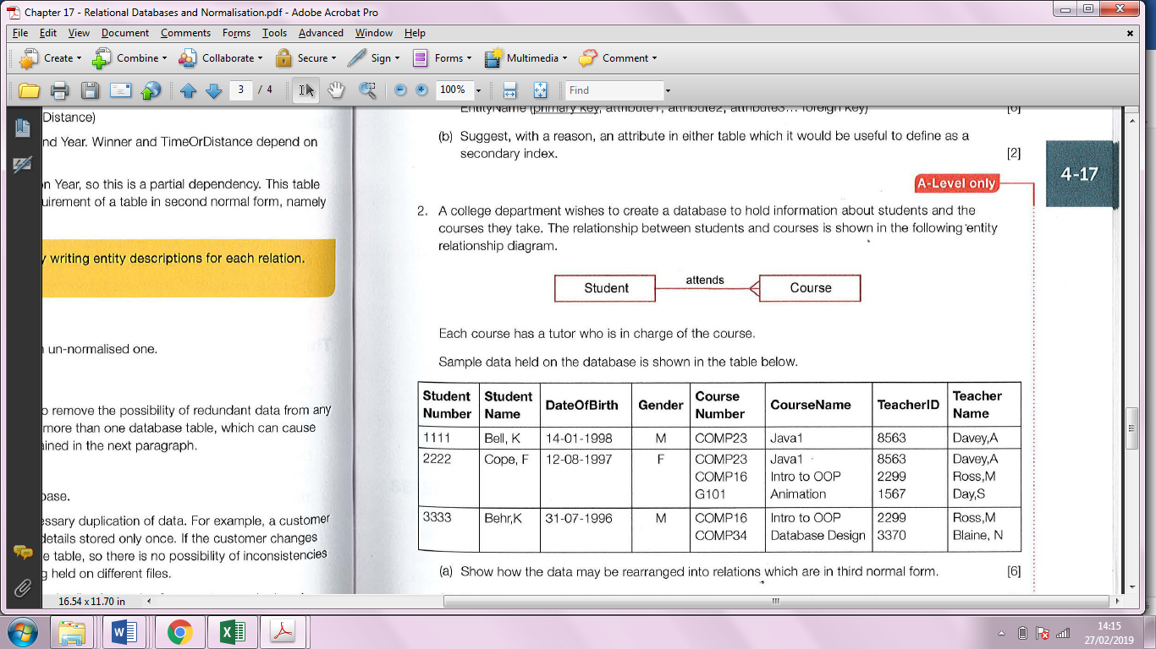

Each course has a tutor who is in charge of the course.

Sample data held on the database is shown in the table below.

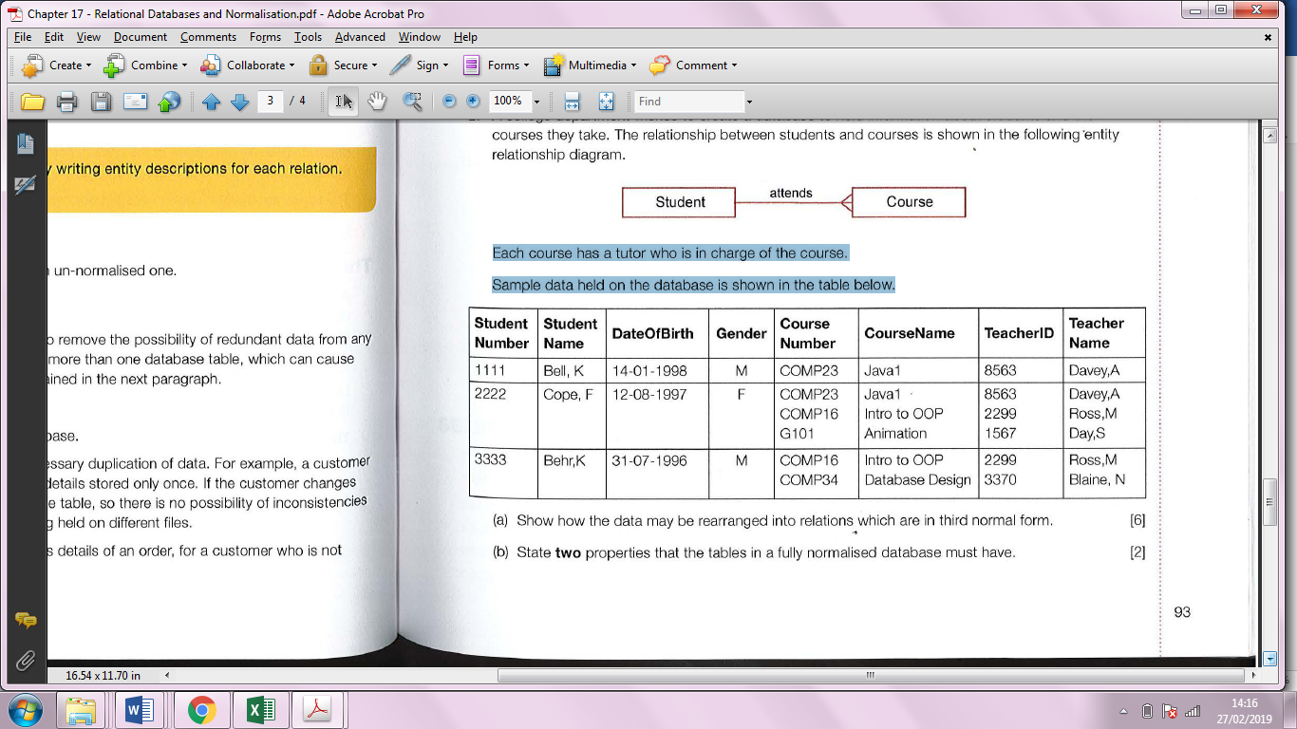

1. Show how the data may be rearranged into relations which are in third normal form.

_______________________________________________________________

_______________________________________________________________

_______________________________________________________________

_______________________________________________________________

_______________________________________________________________

_____________________________________________________________(6)

1. State two properties that the tables in a fully normalised database must have.

_______________________________________________________________

_____________________________________________________________(2)

10. A museum has permanent displays but also runs a programme of special events. People may pay an annual fee to become Friends of the Museum. Friends can attend events, which they must book in advance. This, and other data about the museum, is stored in a relational database. Part of the

entity-relationship (E-R) diagram is shown .

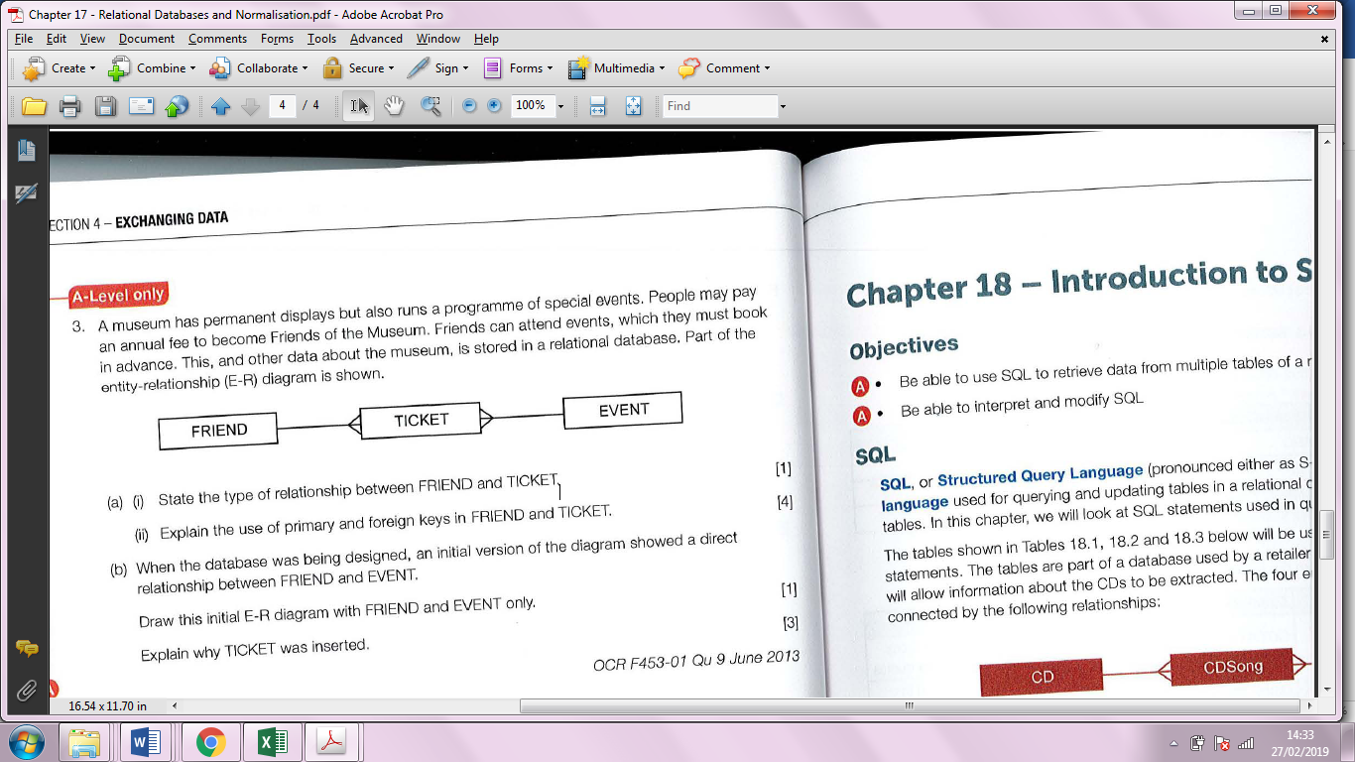

1. (i) State the type of relationship between FRIEND and TICKET.

_____________________________________________________________(1)

(ii) Explain the use of primary and foreign keys in FRIEND and TICKET. _______________________________________________________________

_______________________________________________________________

_______________________________________________________________

_____________________________________________________________(4)

(b) When the database was being designed, an initial version of the diagram showed a direct relationship between FRIEND and EVENT.

Draw this initial E-R diagram with FRIEND and EVENT only.

_____________________________________________________________(1)

Explain why TICKET was inserted.

_______________________________________________________________

_______________________________________________________________

_____________________________________________________________(3)

11. A school keeps record of school trips on a database. There are four tables on the database named PUPIL, TRIP, TEACHER, PUPILTRIP, defined as follows:

PUPIL(PupilID, PupilSurname, PupilFirstName)

TRIP(TripID, Description, StartDate, EndDate, Destination, NumberOfStudents, TeacherID)

TEACHER(TeacherID, Title, FirstName, Surname)

PUPILTRIP(PupilID, TripID)

1. Draw an entity relationship diagram showing the relationship between the entities.(4)

(b) Write SQL statements for each of the following operations:

(i) find the first name and surname of all pupils who went on a trip with TripID 14.

_______________________________________________________________

_______________________________________________________________

_______________________________________________________________

_____________________________________________________________(4)

(ii) find all the trips for which the teacher with surname “Black” has been in charge, giving teacher’s title and surname, trip description and start date, sorted in descending order of start date.

_______________________________________________________________

_______________________________________________________________

_______________________________________________________________

_____________________________________________________________(4)

(iii) find the firstnames and surnames of all the pupils who went on any trip with “Year 7” in the description (e.g. “Year 7 Geography field trip” in May 2015, showing the firstname and surname of the teacher in charge.

_______________________________________________________________

_______________________________________________________________

_______________________________________________________________

_____________________________________________________________(4)

12. A car dealer accepts orders for new vehicles from its customers, and puts in an order to the manufacturer for the customised vehicle(s). There may be more than one vehicle on the customer order if for example a company is replacing its fleet of hire cars. When a car arrives, a member of staff telephones or emails the customer to inform them that it is ready for collection.

Details of the vehicles, customers and orders are to be stored in a relational database using the following four relations:

Vehicle (VehiclelD, VehicleName, Model, Price, SupplierName)

CustomerOrder (OrderID, CustomerlD, Date)

CustomerOrderLine (OrderID, VehiclelD)

Customer (CustomerID, CustomerName, EmailAddress, TelephoneNumber)

(a) These relations are in Third Normal Form (3NF).

(i) What does this mean?

_______________________________________________________________

_____________________________________________________________(2)

(ii) Why is it important that the relations in a relational database are in Third Normal Form?

_______________________________________________________________

_____________________________________________________________(2)

1. On the incomplete entity relationship diagram below show the degree of any three relationships that exist between the entities. (3)

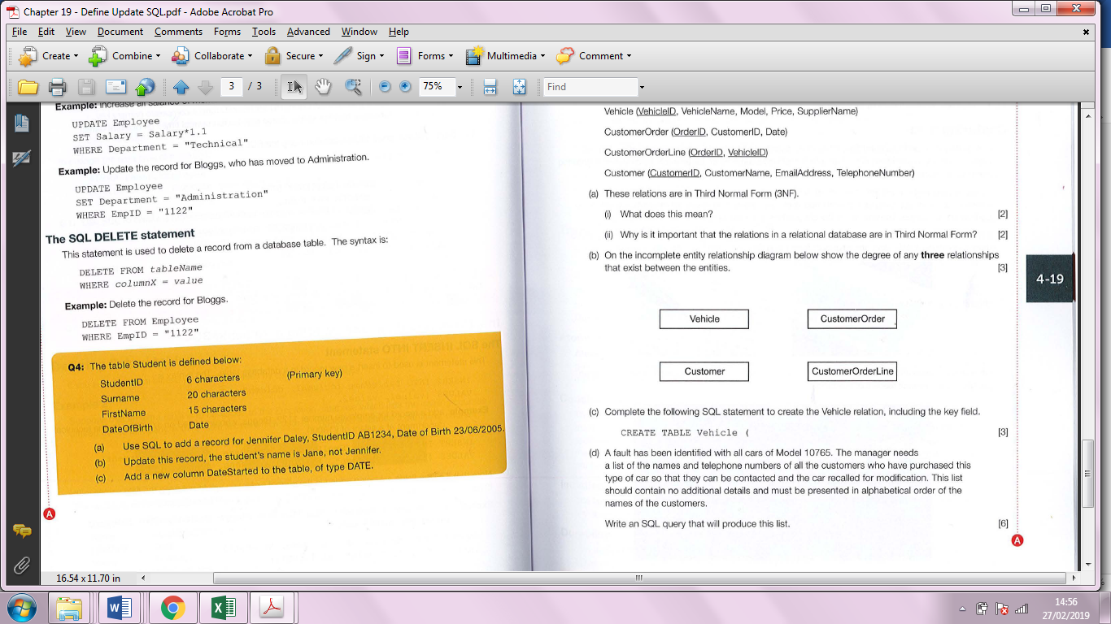

c) Complete the following SOL statement to create the Vehicle relation, including the key field. (3)

CREATE TABLE Vehicle (

(d) A fault has been identified with all cars of Model 10765. The manager needs a list of the names and telephone numbers of all the customers who have purchased this type of car so that they can be contacted and the car recalled for modification. This list should contain no additional details and must be presented in alphabetical order of the names of the customers.

Write an SQL query that will produce this list.

_______________________________________________________________

_______________________________________________________________

_______________________________________________________________

_______________________________________________________________

_______________________________________________________________

_____________________________________________________________(6)

13 (a) Explain how, in a client-server database with multi may not be recorded if the database pie users, an update made by one user to ensure the integrity of the database management system does not have measures in place to ensure the integrity of the database.

_______________________________________________________________

_______________________________________________________________

_____________________________________________________________(3)

1. Explain what is meant by deadlock and how this can arise.

_______________________________________________________________

_____________________________________________________________(2)

(b) Name and describe briefly a method of preventing this from happening.

_______________________________________________________________

_____________________________________________________________(2)

14 (a) Describe what is meant by referential integrity in a database.

_______________________________________________________________

_____________________________________________________________(2)

(b) Describe what is meant by the ACID modeI in database theory.

_______________________________________________________________

_______________________________________________________________

_______________________________________________________________

_______________________________________________________________

_______________________________________________________________

_____________________________________________________________(6)

15. A Uniform Resource locator (URl) is the address of a resource on the Internet. For example,

http://www.pgonline.co.uk/courses/alevel/computing_test.html.

Explain the different parts of the address.

(a) www.

_____________________________________________________________(1)

(b) pgonline.co.uk

_____________________________________________________________(1)

(c) /courses/alevel/computing_test.html

_____________________________________________________________(1)

16. A village hall committee is considering purchasing a lease on a web domain to set up a new website to advertise their events. They have been advised to contact an Internet registrar.

(a) Explain the role of an Internet registrar.

_______________________________________________________________

_______________________________________________________________

_____________________________________________________________(3)

(b) What is the primary role of an Internet Service Provider (lSP)?

_____________________________________________________________(1)

17. Mahmood wants to create a small Office network for a home enterprise.

(a) Describe what is meant by a LAN.

_______________________________________________________________

_____________________________________________________________(2)

(b) Suggest **two** items of hardware that would be required to create a wireless LAN.

_______________________________________________________________

_____________________________________________________________(2)

18. All Internet connected devices communicate via the TCP/IP protocol stack. This has four layers - the application, transport, network and link layers.

(a) Describe the roles of each layer when two devices are communicating over the Internet.

_______________________________________________________________

_______________________________________________________________

_______________________________________________________________

_______________________________________________________________

_______________________________________________________________

_______________________________________________________________

_______________________________________________________________

_____________________________________________________________(8)

(b) (i) Give the names of **one** piece of network hardware that operates on the Network layer.

_____________________________________________________________(1)

(ii) Give the names of **one** piece of network hardware that operates on the Link layer.

_____________________________________________________________(1)

19. Major parts of the Internet run on a packet switched network that relies on routers and gateways to communicate.

(a) What is meant by the term packet *switching*?

_______________________________________________________________

_____________________________________________________________(2)

(b) A data packet contains a header and a payload. The header contains data that it used to route the packet to its destination.

State **three** data items that might be contained in a data packet's header.

_______________________________________________________________

_______________________________________________________________

_____________________________________________________________(3)

1. Explain the difference between a *router* and a *gateway*.

_______________________________________________________________

_____________________________________________________________(2)

20. A large company network uses a firewall as part of its security.

(a) What is meant by a 'firewall'?

_______________________________________________________________

_____________________________________________________________(2)

(b) The company also uses anti-virus software as protection against worms, viruses and Trojans.

(i) Give **one** reason why the anti-virus software should be kept up-to-date.

_____________________________________________________________(1)

(ii) State the difference between worms, viruses and Trojans.

_______________________________________________________________

_______________________________________________________________

_____________________________________________________________(3)

21. Malicious attacks on systems are frequently identified and blocked by various systems.

(a) How might a proxy server reduce the risks of malware attacks on a network?

_____________________________________________________________(1)

(b) Give three methods that school systems administrators can use to reduce the threat of malware.

_______________________________________________________________

_______________________________________________________________

_____________________________________________________________(3)

(c) Explain how the use of a proxy server may make access to websites faster for users.

_______________________________________________________________

_____________________________________________________________(2)

22. A website has the following HTML code.

<html>

<head>

<title>Garden Roses</title>

</head>

<body>

<h1 style=”font-family:Arial; color:red”>Species</h1>

<p>There are over 100 species of rose.</p>

<!-Part b-->

<ul>

<li>Climbing roses</li>

<li>Shrub roses</li>

<li>Rambling roses</li>

</ul>

</body>

</html>

(a) Sketch and annotate the website as it would appear in a browser. (4)

(b) The site owner would like to add a hyperlinked image rose.jpg in place of the comment <!—Part b- - >. The image would link to the website <http://www.roses.com>.

Write the code to enable this.

_______________________________________________________________

_______________________________________________________________

_____________________________________________________________(3)

(c) Heading 1 <h1> has had some styles applied using inline CSS.

(i) Give **one** advantage of using CSS styles within the HTML document.

_____________________________________________________________(1)

(ii) Give **two** advantages of using an external CSS style sheet.

_______________________________________________________________

_____________________________________________________________(2)

(d) An external CSS style sheet is added to the web page. This contains three rules. Describe what effect if any these rules will have on the appearance of the web page. Where there is no effect, this should be stated.

1. body {background-color: lightGreen}

_____________________________________________________________(1)

1. p.bold {font-weight: bold}

_____________________________________________________________(1)

1. h1 {text-align: center}

_____________________________________________________________(1)

1. The text within the <ul> tags needs to be styled in green with the intention that any other lists added to the page share the same style. Explain how this can be achieved.

_______________________________________________________________

_______________________________________________________________

_____________________________________________________________(3)

23. Cascade Style Sheets (CSS) make use of **.classes** and **#identifiers.**

(a) Explain the difference between them giving an example of when each might be used.

_______________________________________________________________

_____________________________________________________________(2)

(b) Explain how a CSS style defined as a class or identifier may be applied to a specific section of the HTML content.

______________________________________________________________

_____________________________________________________________(2)

24. A website contains Javascript code.

(a) Describe what is meant by the term *JavaScript*.

______________________________________________________________

_____________________________________________________________(2)

(b) Explain why JavaScript is usually interpreted rather than compiled .

______________________________________________________________

_____________________________________________________________(2)

25. The website www.postrates.com offers a rate check service for sending letters and parcels. The homepage contains a button hyperlinked to the following webpage:

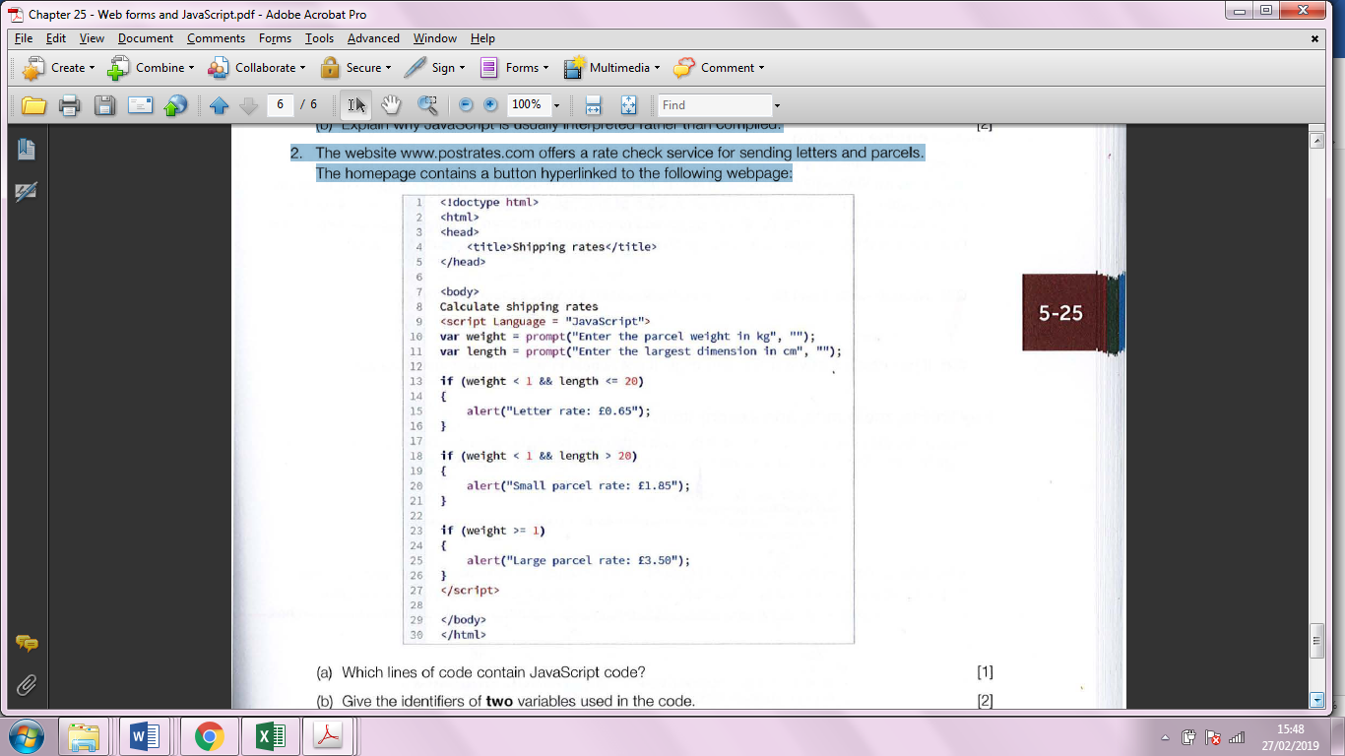

(a) Which lines of code contain JavaScript code?

_____________________________________________________________(1)

(b) Give the identifiers of **two** variables used in the code.

______________________________________________________________

_____________________________________________________________(2)

(c) Looking at the webpage code, what is the purpose of the JavaScript function called *prompt* on line 10?

______________________________________________________________

_____________________________________________________________(2)

(d) When the webpage is requested, what would happen if a parcel weight of 1 kg and a maximum length of 10cm is entered?

______________________________________________________________

_____________________________________________________________(2)

**ADD QUESTIONS FROM PAGE 146!!**

25. Explain the difference between client-server and peer-to-peer networking, and give an example of where each might be used.

_______________________________________________________________

_______________________________________________________________

_______________________________________________________________

_______________________________________________________________

_______________________________________________________________

_____________________________________________________________(6)

26. A travel agency is planning to install a new computer system based on the client-server model, for its agents to use for flight and hotel bookings and enquiries at multiple workstations.

(a) What is meant by the client-server model?

_______________________________________________________________

_____________________________________________________________(2)

After some consideration, the company has decided to use a thin-client network.

(b) Explain how a thin-client network operates.

_______________________________________________________________

_______________________________________________________________

_____________________________________________________________(3)

(c) How would the decision to use a thin- rather than thick-client network affect the choice of hardware?

_______________________________________________________________

_____________________________________________________________(2)

27. A company is designing a website which will allow its customers to place orders online. The individual web pages that describe each product will be generated dynamically using server-side scripting.

Explain what a server-side script is.

_______________________________________________________________

_____________________________________________________________(2)

28. A website is set up to enable users to access on-demand television programs. Users can sign up to the website and download a recent series episode or film. Programs are downloaded and stored on the user's device. When others choose to download the same program, parts of the program data may come from multiple devices belonging to other users.

(a) State what this model of network is called.

_____________________________________________________________(1)

(b) (i) Give **one** advantage to the company of this model.

_____________________________________________________________(1)

(ii) Give **one** advantage to the user of this model.

_____________________________________________________________(1)

(c) JavaScript is used to validate that the user's email address is in a valid format when a booking is made.

(i) Give **two** advantages of client-side validation.

_______________________________________________________________

_____________________________________________________________(2)

(ii) Client- and server-side validation should happen in partnership. Explain why it is important to validate the email address again once it reaches the server.

_______________________________________________________________

_____________________________________________________________(2)