Web Technologies - HTML

**Introduction**

For this qualification, it is stated that you must understand some basic HTML, CSS and Java Script code. But what is HTML, CSS and Java Script and why is it needed?

These questions will be explain over the next few workbooks.

**HTML, CSS and Java Script**

There are three main languages of the web:

**HTML**

**CSS**

**JavaScript**

**HTML**…the structural layer

“Code which tells the browser how text and images should be structured on the screen”

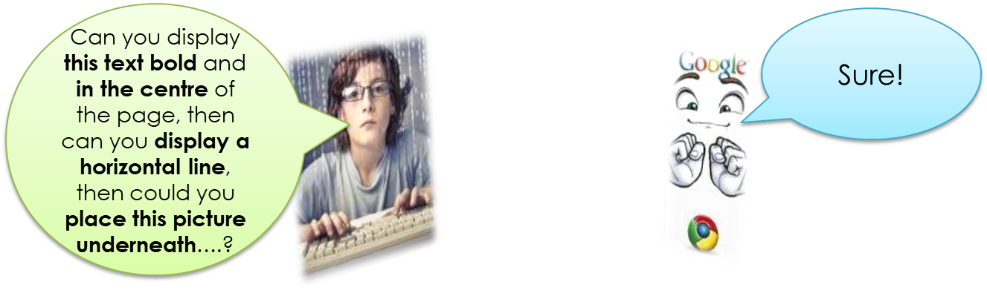

**CSS**…the presentation layer

“Code which tells the browser how text and images should be presented on the screen”

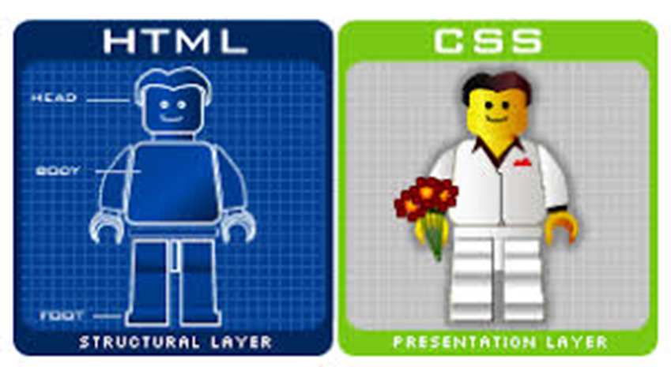

**JavaScript**…the behaviour layer

“Code which allows users to interact with the page content”

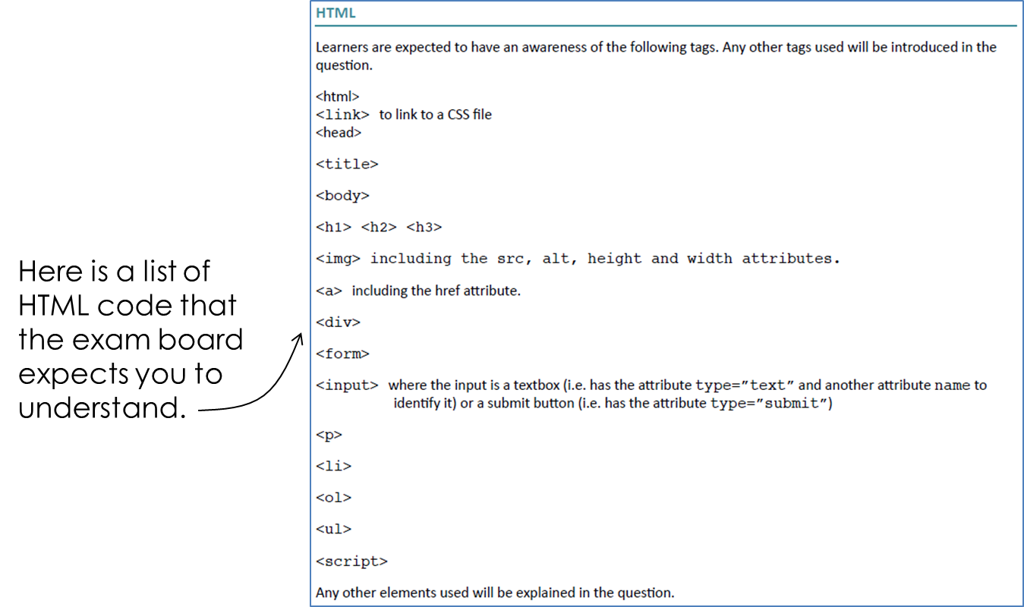**What you need to know - HTML**

HTML consists of tags. Many of these come in pairs.

At its most basic level, a webpage is structured with three main pairs of tags.

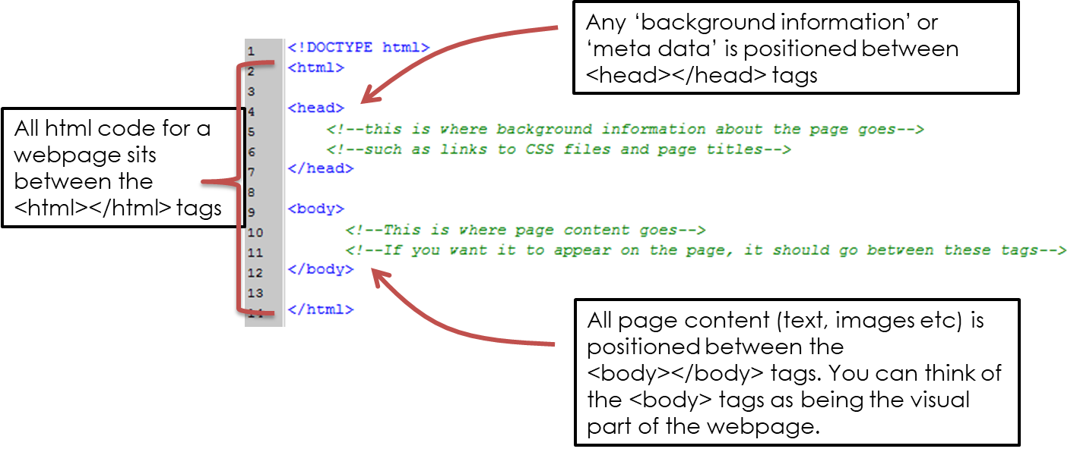

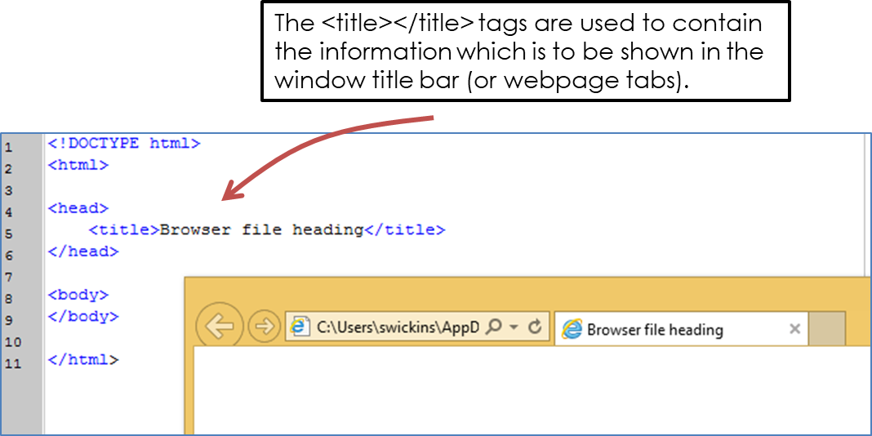***Title Tags***

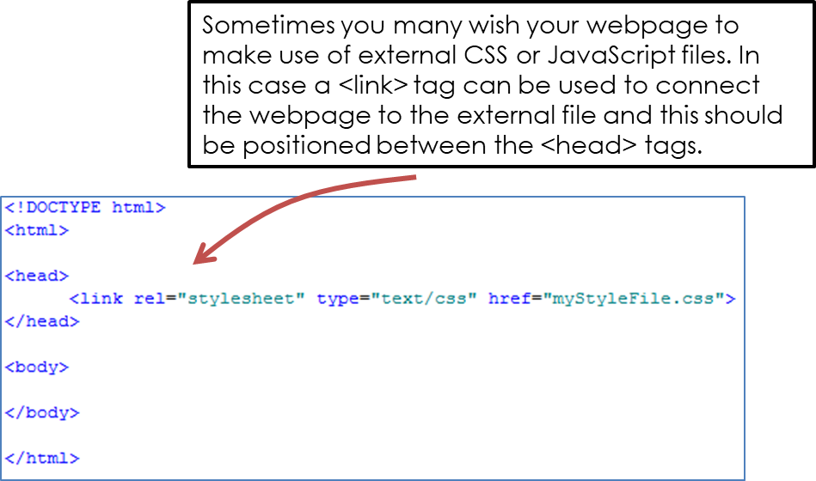***Link Tags***

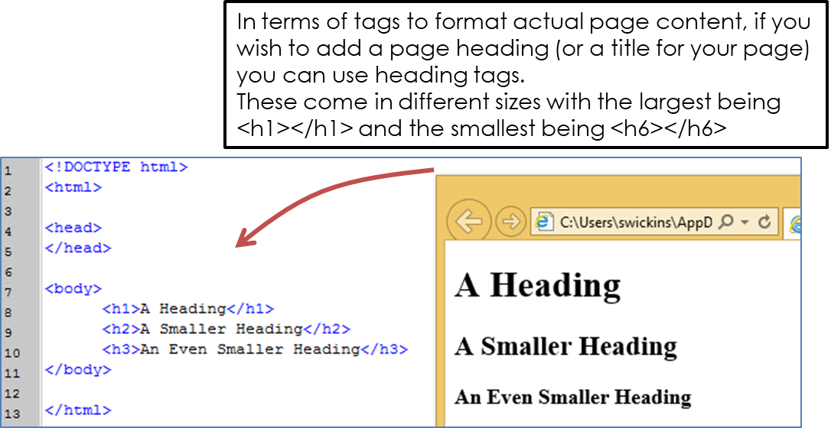***Heading Tags***

***Image Tags***

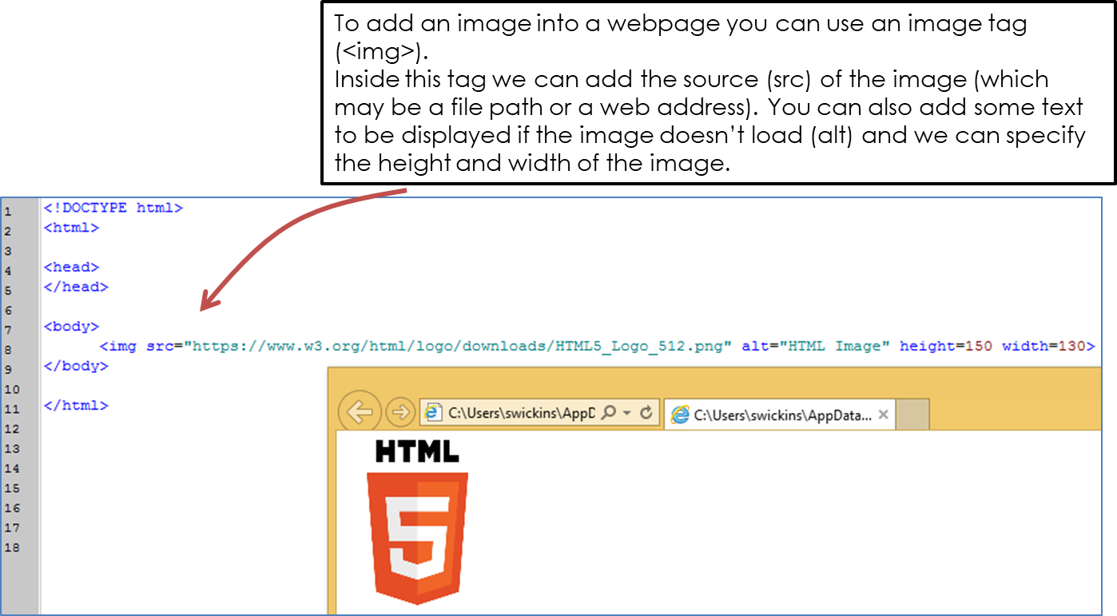

***Anchor Tags***

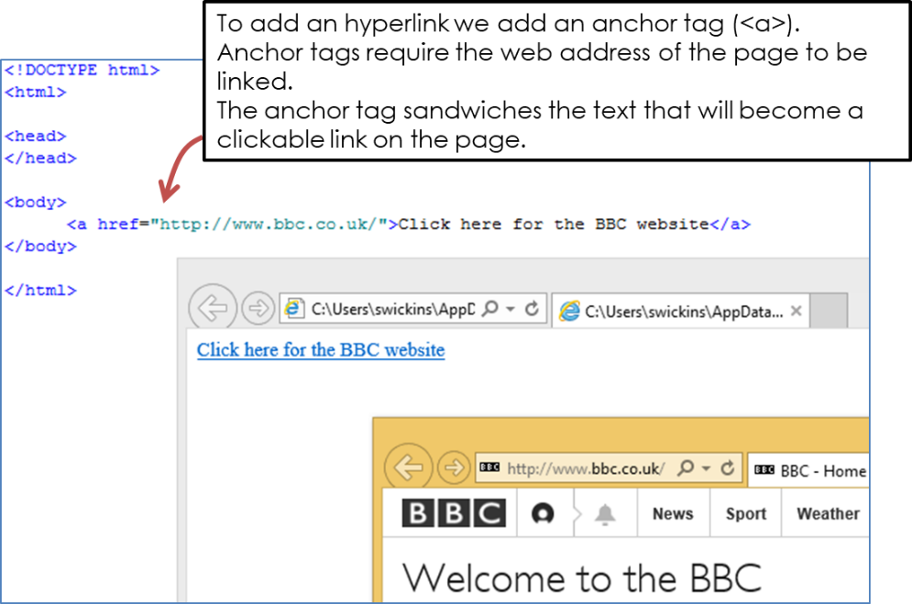

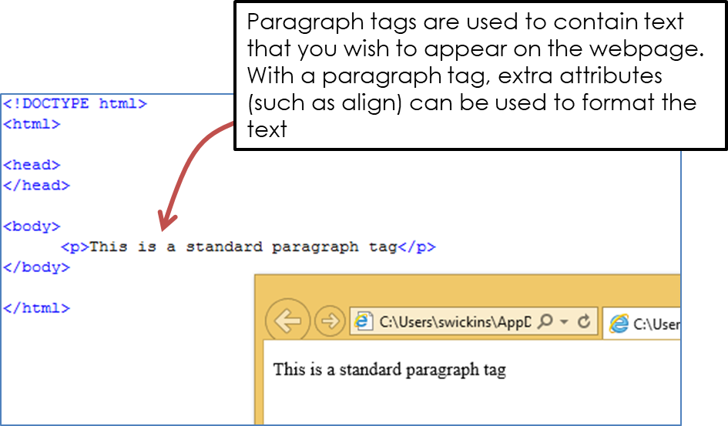***Paragraph Tags***

***List Tags***

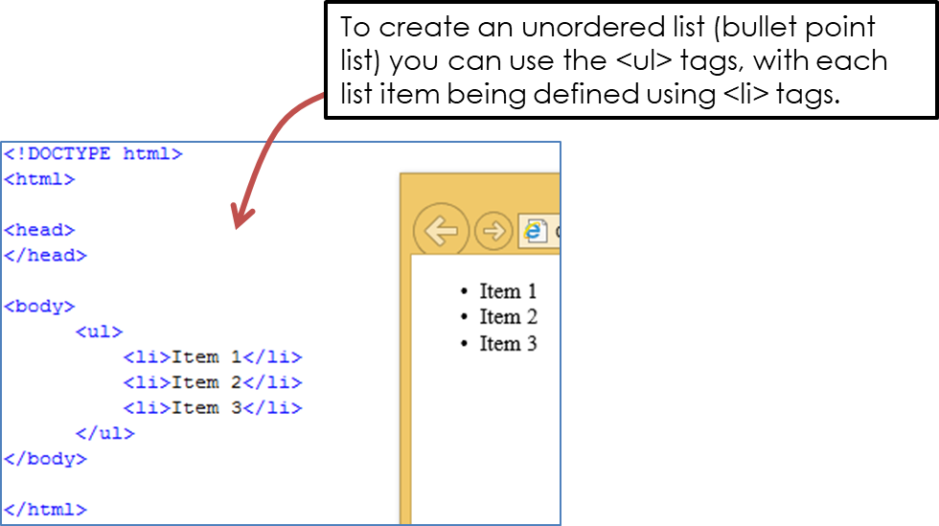

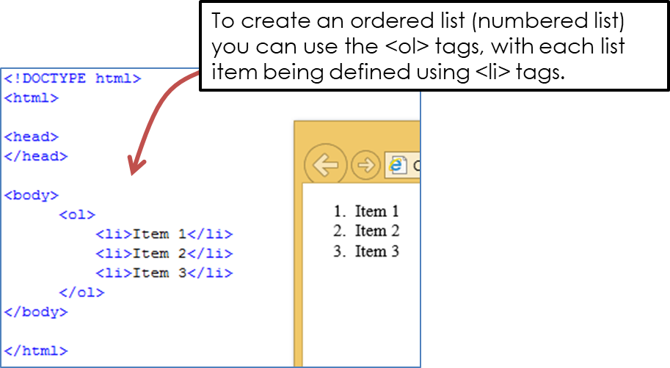

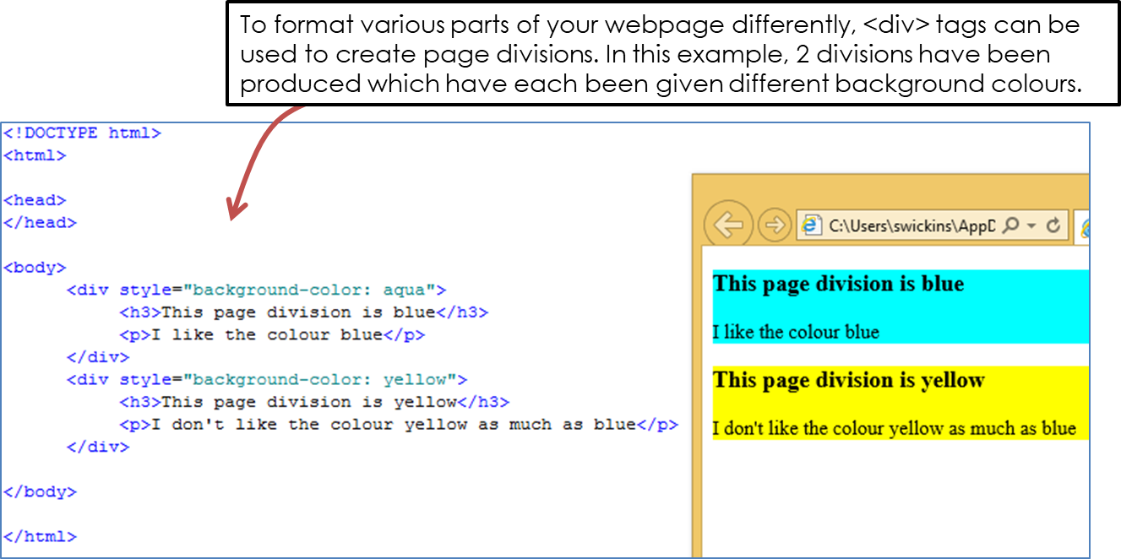***Division Tags***

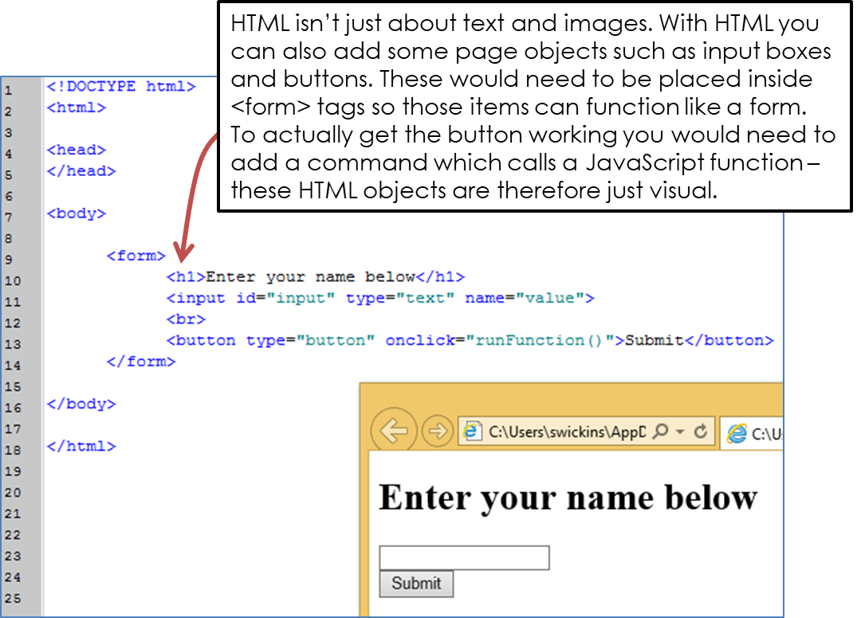

***Form Tags***

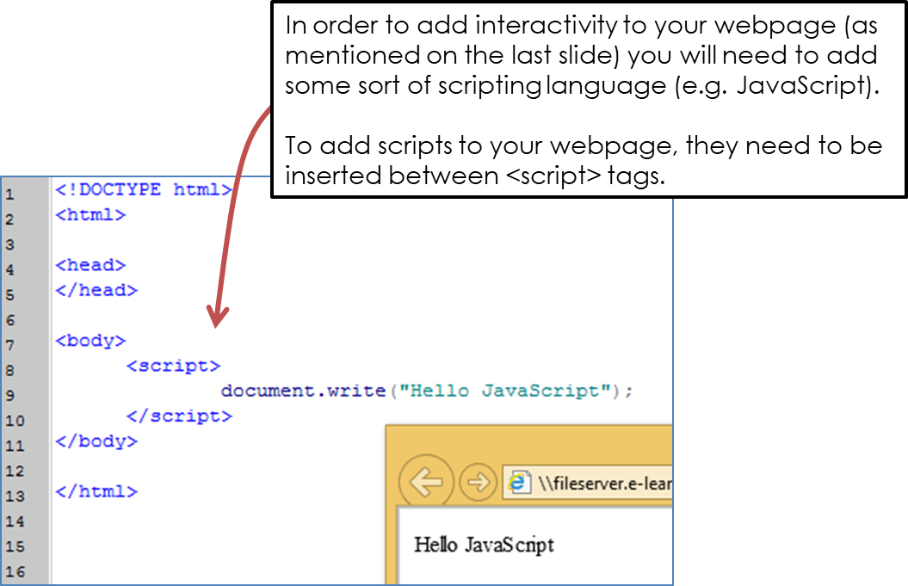

***Script Tags***

**‘Application and Challenge’ Class Activity**

1. Make a webpage of your choice which contains all the required HTML knowledge for this course. [10]

* Make your page interesting.
* Add more than the minimum requirements.

**Questions**

1. Study the following webpage and write the HTML code that created it.

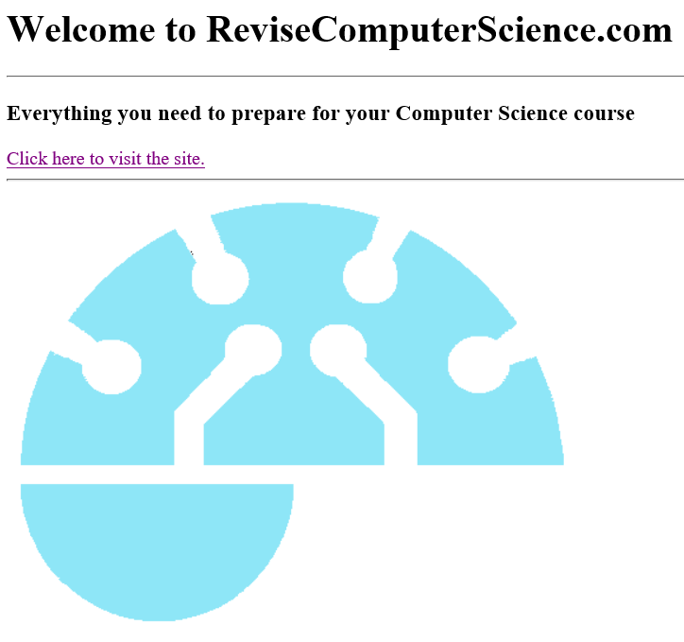

1. Study the following HTML code and draw the webpage that it would create. [6]

