1.4 Data types, data structures and algorithms

Topic Area | Sub Topic | How I feel
 |  | Red | Amber | Green
1.4.1 Data Types | Primitive data types, integer, real/floating point, character, string and Boolean
 |  | Your notes
1.4.1 Data Types | Represent positive integers in binary
 |  | Your notes
1.4.1 Data Types | Use of sign and magnitude and two’s complement to represent negative numbers in binary.
 |  | Your notes
1.4.1 Data Types | Addition and subtraction of binary integers
 |  | Your notes
1.4.1 Data Types | Represent positive integers in hexadecimal.
 |  | Your notes
1.4.1 Data Types | Convert positive integers between binary hexadecimal and denary.
 |  | Your notes
1.4.1 Data Types | Representation and normalisation of floating point numbers in binary
 |  | Your notes
1.4.1 Data Types | Floating point arithmetic, positive and negative numbers, addition and subtraction
 |  | Your notes
1.4.1 Data Types | Bitwise manipulation and masks: shifts, combining with AND, OR, and XOR.
 |  | Your notes
1.4.1 Data Types | How character sets (ASCII and UNICODE) are used to represent text.
 |  | Your notes
1.4.2 Data Structures | Arrays (of up to 3 dimensions), records, lists, tuples
 |  | Your notes
1.4.2 Data Structures | The following structures to store data: linked-list, graph (directed and undirected), stack, queue, tree, binary search tree, hash table.
 |  | Your notes
1.4.2 Data Structures | How to create, traverse, add data to and remove data from the data structures mentioned above. (NB this can be either using arrays and procedural programming or an object-oriented approach)
 |  | Your notes
1.4.3 Boolean Algebra | Define problems using Boolean logic.
 |  | Your notes
1.4.3 Boolean Algebra | Manipulate Boolean expressions, including the use of Karnaugh maps to simplify Boolean expressions
 |  | Your notes
1.4.3 Boolean Algebra | Use the following rules to derive or simplify statements in Boolean algebra: De Morgan’s Laws, distribution, association, commutation, double negation
 |  | Your notes
1.4.3 Boolean Algebra | Using logic gate diagrams and truth tables
 |  | Your notes
1.4.3 Boolean Algebra | The logic associated with D type flip flops, half and full adders
 |  | Your notes

Exam Questions
- A school keeps data about each of its pupils. State the most suitable data type for each of the following data items (5)

- Pupil's surname
______________________________________________
- A single letter indicating whether they are male or female
______________________________________________
- The amount owed for school trips
______________________________________________
- The number of school trips they have participated in
______________________________________________
- Whether or not the pupil is entitled to free school meals
______________________________________________

- Represent the denary number 123 in binary using 8 bits.

_____________________________________________________________(1)

- How many different denary numbers can be represented using 8-bit binary?

_____________________________________________________________(1)

4. What is the hexadecimal equivalent of the denary number 123?

_____________________________________________________________(1)

5. Why are bit patterns often displayed using hexadecimal instead of binary?

_______________________________________________________________

_____________________________________________________________(2)

(c)RLE encoding is a lossless compression method, Give one disadvantage of loss less compression over lossy methods for the compression of images.

_____________________________________________________________(1)

6. Figure 1 shows the contents of a memory location.

1 | 0 | 1 | 0 | 0 | 1 | 1 | 1
Figure 1
What is the denary equivalent of the contents of this memory location if it represents an unsigned binary integer?

_____________________________________________________________(1)

7. What is the hexadecimal equivalent of the binary pattern shown in Figure 1?

_____________________________________________________________(1)

8. Convert the hexadecimal number DA to denary.

_____________________________________________________________(1)
9. The ASCII system uses 7 bits to represent a character. The ASCII code in denary for the numeric character '0' is 48; other numeric characters follow on from this in sequence.
(a) Using 7 bits, what is the ASCII code for the character '2' in binary?

_____________________________________________________________(1)

(b) How many different characters can be represented using ASCII?

_____________________________________________________________(1)

10. One character encoding scheme is Unicode. An alternative character encoding scheme is ASCII.
(a) State one difference between Unicode and ASCII.

_____________________________________________________________(1)

(b) State one advantage and one disadvantage of using ASCII rather than Unicode for representing characters.

_______________________________________________________________

_____________________________________________________________(2)

11. How many times greater is the storage capacity of a 1 terabyte hard disk drive than that of a 256 megabyte hard disk drive?
Show each stage of your working.

_______________________________________________________________

_____________________________________________________________(2)

12. Represent the denary value -1 g as an 8-bit two's complement binary integer.

_______________________________________________________________

_____________________________________________________________(2)

13. What is the largest positive denary value that can be represented using 8-bit two's complement binary?

_____________________________________________________________(1)

14. Describe how 8-bit two's complement binary can be used to subtract one number from another number. In your answer show how the calculation 25 - 49 would be completed using the method that you have described.

_______________________________________________________________

_____________________________________________________________(2)

15. A computer stores the current temperature of a supermarket delivery van. The temperature in °C is stored as a two's complement integer using a single byte.
(a) Convert the freezer temperature value of -19 into binary.

_______________________________________________________________

_____________________________________________________________(2)

(b) State the range of temperature values that can be stored using 8 bits.

_____________________________________________________________(2)

16. A memory location contains the value 10101011. What is its denary equivalent if it represents a two's complement binary integer?

_______________________________________________________________

_____________________________________________________________(2)

17. A normalised floating point representation uses an 8-bit mantissa and a 4-bit exponent, both stored using two's complement format.

- This is a floating point representation of a number:
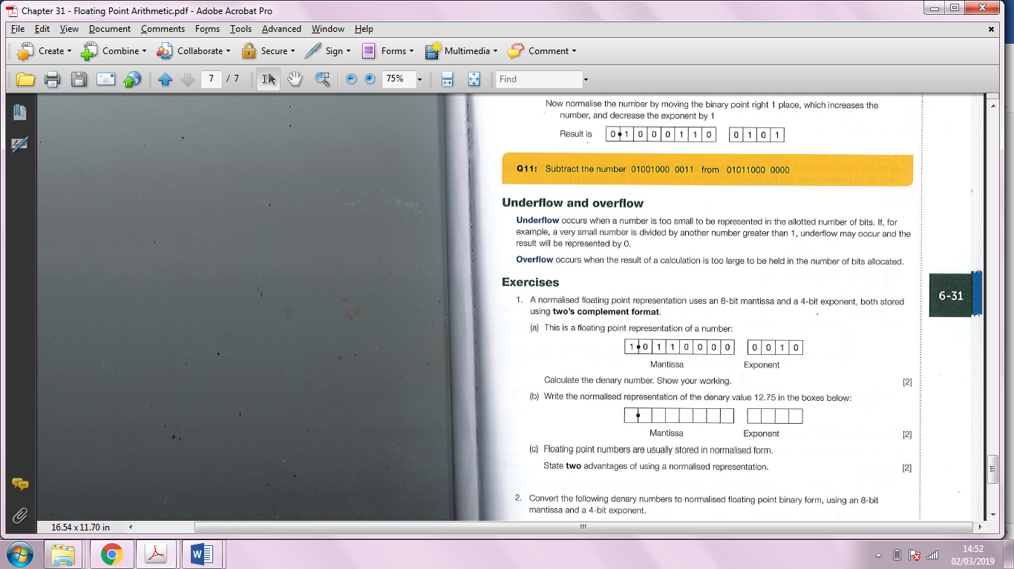

Calculate the denary number. Show your working.

_______________________________________________________________

_____________________________________________________________(2)

(b)Write the normalised representation of the denary value 12.75 in the boxes below: (2)

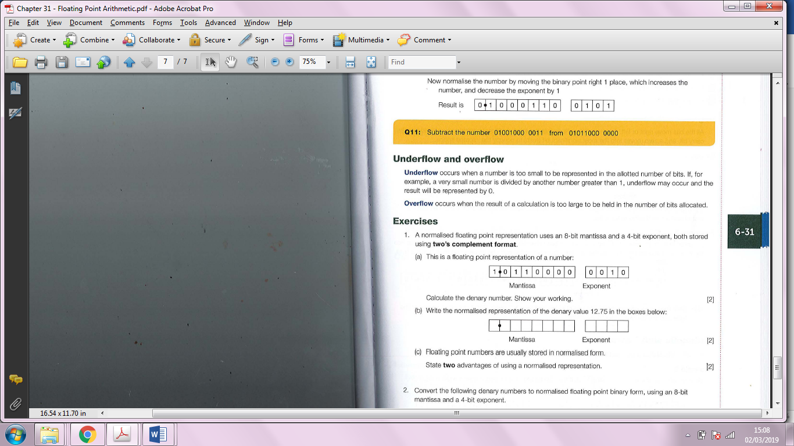
(c) Floating point numbers are usually stored in normalised form.
State two advantages of using a normalised representation.

_______________________________________________________________

_____________________________________________________________(2)

18. Convert the following denary numbers to normalised floating point binary form, using an 8-bit mantissa and a 4-bit exponent.
(a) -18.75

_______________________________________________________________

_____________________________________________________________(2)

(b) 0.0625

_______________________________________________________________

_____________________________________________________________(2)

19. An 8-bit word holds the binary pattern 10110010. Start with this bit pattern in each of parts (a), (b) and (c). There is no need to show the contents of the carry bit.

- State the contents of the word after a logical left shift of 2 bits.

_____________________________________________________________(1)

- Interpreting the word as a number in two's complement form, state the contents of the word after an arithmetic right shift of 2 bits.

_____________________________________________________________(1)

- State the contents of the word after a circular shift left of 3 bits.

_____________________________________________________________(1)

20. In a particular computer, characters are represented in 8 bits using the ASCII code.

The codes for uppercase letters are from 0100 0001 for A to 0101 1010 for Z.

The codes for lowercase letters are from 0110 0001 for a to 0111 1010 for z.

Give an 8-bit mask and the appropriate logical operation which will:
- change any uppercase letter into its lowercase equivalent

_______________________________________________________________

_____________________________________________________________(2)

- change any lowercase letter into its uppercase equivalent.

_______________________________________________________________

_____________________________________________________________(2)

21. A 32-bit register holds a four byte value. The bytes are numbered so that the first byte is leftmost. What mask and logical operator is required to achieve each of the following results:
(a) complement the second byte

_______________________________________________________________

_____________________________________________________________(2)

(b) set the third byte to zero?
_______________________________________________________________

_____________________________________________________________(2)

22. (a) Explain why the for... next loop repeated below is not the most efficient type of loop in this Situation.

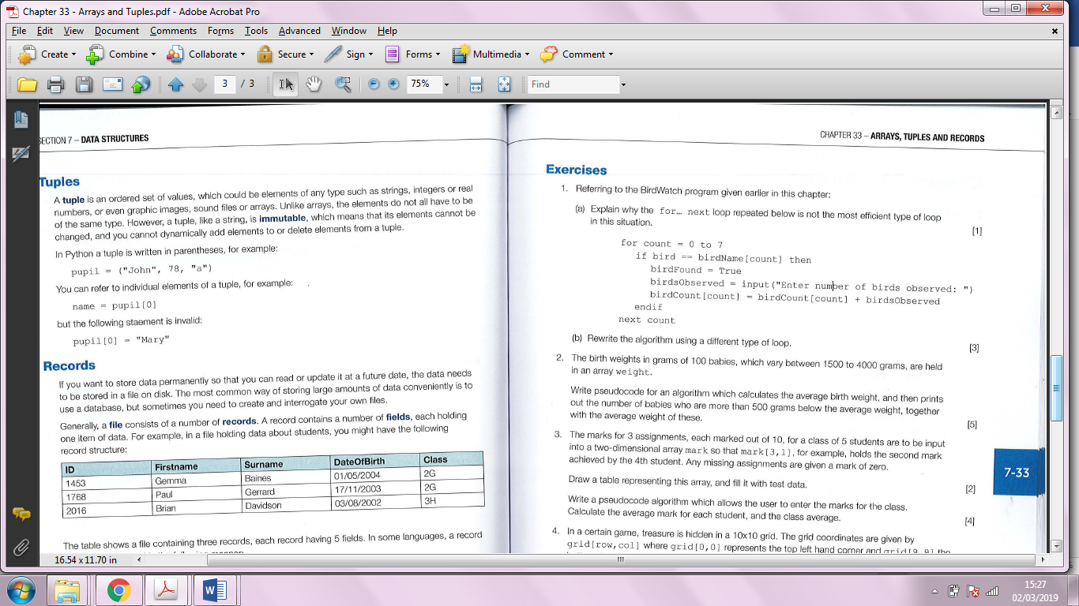

_____________________________________________________________(1)

(b) Rewrite the algorithm using a different type of loop. (3)

23. The birth weights in grams of 100 babies, which vary between 1500 to 4000 grams, are held in an array weight.
Write pseudocode for an algorithm which calculates the average birth weight, and then prints out the number of babies who are more than 500 grams below the average weight, together with the average weight of these.(5)

24. The marks for 3 assignments, each marked out of 10, for a class of 5 students are to be input into a two-dimensional array mark so that mark [3 , 1] , for example, holds the second mark achieved by the 4th student. Any missing assignments are given a mark of zero.
Draw a table representing this array, and fill it with test data.(2)

Write a pseudocode algorithm which allows the user to enter the marks for the class. Calculate the average mark for each student, and the class average.(4)

25. In a certain game, treasure is hidden in a 10x10 grid. The grid coordinates are given by grid [row, col] where grid [0, 0] represents the top left hand corner and grid [ 9, 9] the bottom right corner. The grid coordinates of the treasure are signified by a 1 at grid [row, col ] .
All other grid elements are filled with zeros.
What is the purpose of the following pseudocode algorithm?

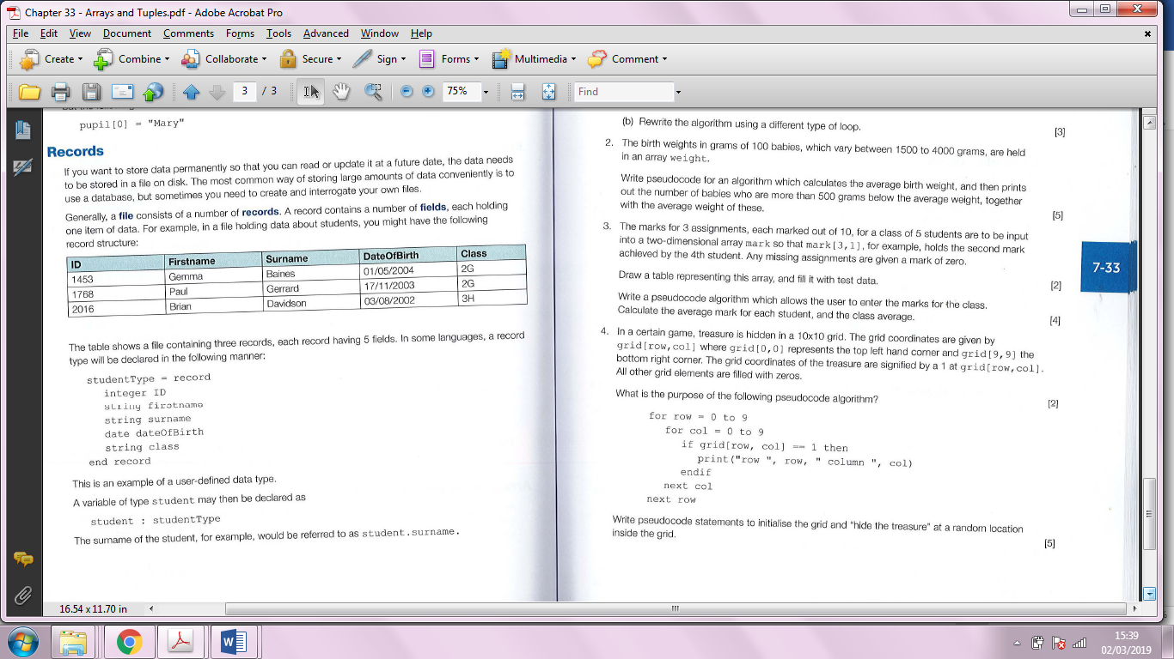

_______________________________________________________________

_____________________________________________________________(2)

Write pseudocode statements to initialise the grid and "hide the treasure" at a random location inside the grid. (5)

26.(a) Explain why a queue may be implemented as a circular queue.

_______________________________________________________________

_____________________________________________________________(2)

(b) Explain what is meant by a dynamic data structure and why an inbuilt dynamic data structure in a programming language may be useful in implementing a queue.

_______________________________________________________________

_____________________________________________________________(2)

(c) Print jobs are put in a queue to be printed. The queue is implemented in an array, indexed from 0, as a circular queue which can hold 5 jobs. Jobs enter the queue in the sequence Job1, Job2, Job3, Job4, Job5, Pointers front and rear point to the first and last items in the queue respectively,
(i) Draw a diagram to show how the print jobs are stored, Include pointers in your diagram , (3)

(ii) Two jobs are printed and leave the queue, Another job, Job6, joins the queue,
Draw a diagram representing the new situation, (2)

27. The size of some data structures is fixed when the structure is created,
(a) State the term used to describe such data structures.
Give one example of a type of data structure whose size is always fixed.
Give one advantage of using a fixed size data structure.

_______________________________________________________________

_______________________________________________________________

_____________________________________________________________(3)

(b) A queue data structure has two painters called front and next which are defined as:
front points to the first item in the queue
next points to the next available space

The queue is defined as a first in, first out (FIFO) data structure,
(i) State the condition of the pointers when the queue is empty.

_____________________________________________________________(1)

(ii) Write an algorithm to remove one data item from a queue. (4)

- The queue may be represented by a fixed size data structure
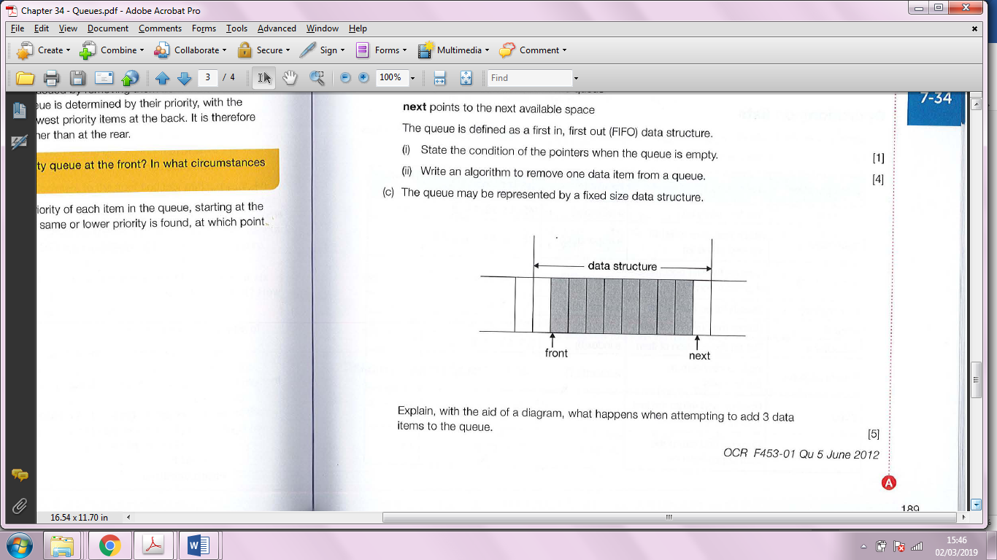

Explain, with the aid of a diagram, what happens when attempting to add 3 data items to the queue (5)

28. A list data structure can be represented using an array.
The pseudocode algorithm below can be used to carry out one useful operation on a list.
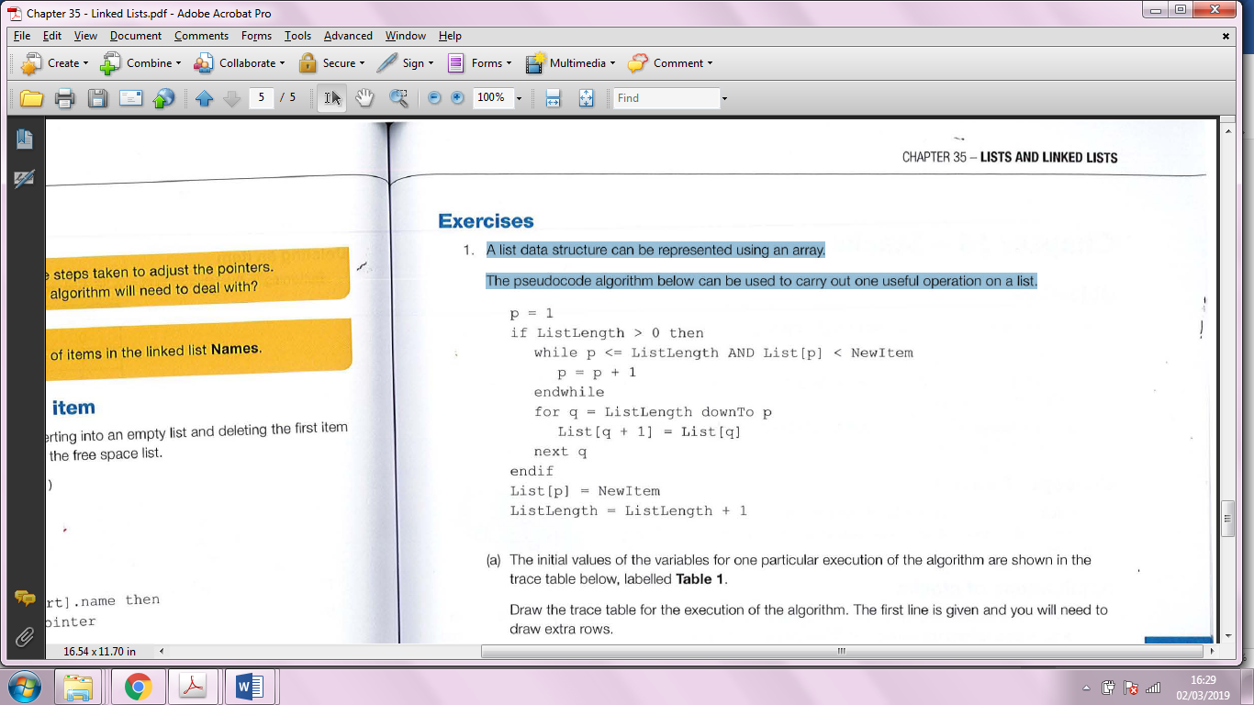
(a) The initial values of the variables for one particular execution of the algorithm are shown in the trace table below, labelled Table 1 .
Draw the trace table for the execution of the algorithm. The first line is given.

 |  |  |  | List
ListLength | New | p | q | [1] | [2] | [3] | [4] | [5]
4 | 38 | - | - | 9 | 21 | 49 | 107

(b) Describe the purpose of the algorithm in Figure 1.

_____________________________________________________________(1)

(c) A list implemented using an array is a static data structure. The list could be implemented using a linked list as a dynamic data structure instead.
Describe one difference between a static data structure and a dynamic data structure.

_____________________________________________________________(1)

29. (a) The birds Robin, Sparrow, Blackbird, are entered, in the order given, into a linked list so that they may be processed alphabetically. Draw a diagram of this linked list. (2)

(b) Redraw the diagram after two additional items, Chaffinch and Goldfinch, are added. (2)

(c) Show the list implemented in an array of records, with each node holding a data item and a pointer, after the addition of the new items.(4)

(d) Write a pseudocode algorithm to print out the birds in the list in alphabetical order. (4)

30. A Last In, First Out (LIFO) data structure has a pointer called top.
(a) What is this type of data structure known as?

_____________________________________________________________(1)

(b) Name and briefly describe one type of error that that could occur when attempting to add a data item or remove a data item from the data structure.

_______________________________________________________________

_____________________________________________________________(2)

(c) Describe briefly one use of this type of data structure in a computer system.

_______________________________________________________________

_____________________________________________________________(2)

(d) Write a pseudocode procedure for reversing the elements of a queue with the aid of a stack. (6)

31 .Student records held by a school are stored in a database which organises the data in files using hashing.
- In the context of storing data in a file, explain what a hash function is.

_____________________________________________________________(1)

- The system allows for a maximum of 1000 unique 6-digit integer student IDs in the file holding current student records. Give an example of a hashing function that could be used to find a particular record. Ignore collisions.

_______________________________________________________________

_____________________________________________________________(2)

32. A bank has a number of safety deposit boxes in which customers can store valuable documents or possessions. The details of which box is rented by a customer with a particular account number are held in a dictionary data structure. Sample entries in the dictionary are:
{0083456: 'e11', 0154368: 'B74', 11 78612: 'B6', 0567123: 'A34'}

- What value will be returned by a lookup operation using the key 1178612?
_____________________________________________________________(1)

(b) The dictionary is implemented using a hash table, using the algorithm
accountNumber mod 500
What value is returned by the hashing function when it is applied to account number 0093421?

_____________________________________________________________(1)

(c)What is the maximum number of entries that can be made in the dictionary?

_____________________________________________________________(1)

(d)(i) Explain what is meant by a collision.

_____________________________________________________________(1)

(ii) Give an example of how a collision might occur in this scenario, using sample account numbers.

_______________________________________________________________

_____________________________________________________________(2)

(iii) Describe one way of dealing with collisions in the hash table.

_____________________________________________________________(1)

- The figure below shows an adjacency matrix representation of a directed graph (digraph).

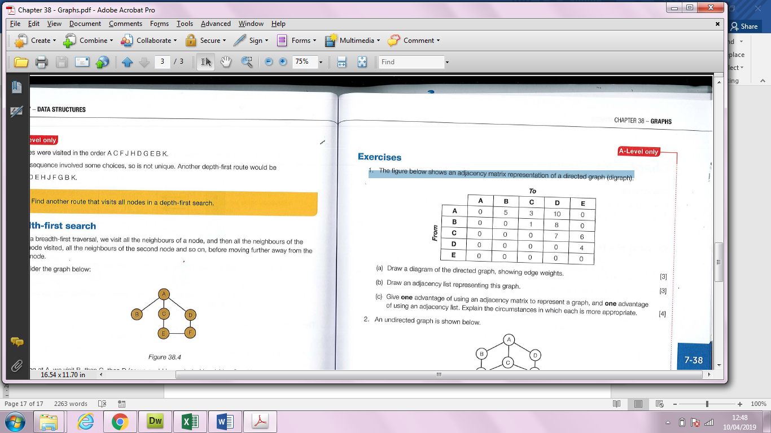

- Draw a diagram of the directed graph, showing edge weights. (3)

- Draw an adjacency list representing this graph. (3)

- Give one advantage of using an adjacency matrix to represent a graph, and one advantage of using an adjacency list. Explain the circumstances in which each is more appropriate.

_______________________________________________________________

_______________________________________________________________

_______________________________________________________________

_____________________________________________________________(4)

- An undirected graph is shown below.

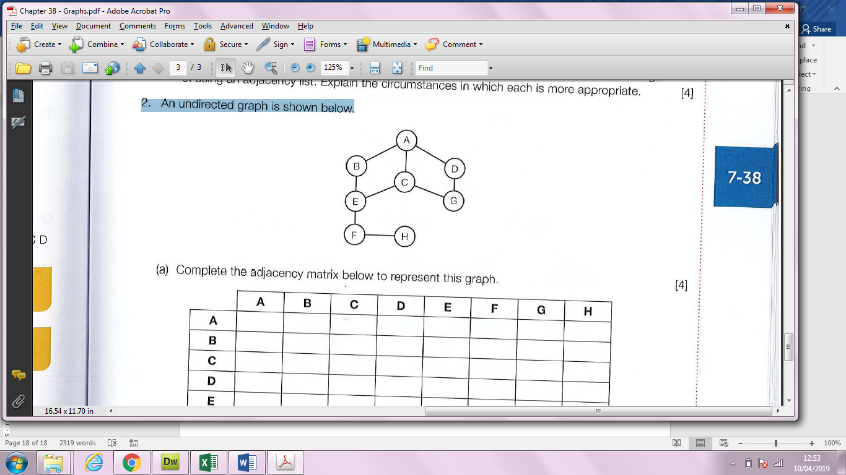

- Complete the adjacency matrix below to represent this graph. (4)

 | A | B | C | D | E | F | G | H
A
B
C
D
E
F
G
H

(b) List the nodes in the order in which they would be visited using
(i) a depth-first search

_______________________________________________________________

_______________________________________________________________

_____________________________________________________________(3)

(ii) a breadth-first search

_______________________________________________________________

_______________________________________________________________

_____________________________________________________________(3)

35. Data may be stored as a binary tree.
(a) Show how the following data may be stored as a binary tree for subsequent processing in alphabetic order by drawing the tree. Assume that the first item is the root of the tree and the rest of the data items are inserted into the tree in the order given,

Data items: magpie, robin, chaffinch, linnet, thrush, blackbird, fieldfare, skylark, pigeon.

_______________________________________________________________

_______________________________________________________________

_____________________________________________________________(3)

- Show how the data could be represented using three one-dimensional arrays.

_______________________________________________________________

_______________________________________________________________

_____________________________________________________________(3)

(c) List the order that the nodes would be visited using
(i) a pre-order traversal

_______________________________________________________________

_____________________________________________________________(2)

(ii) an in ·order traversal

_______________________________________________________________

_____________________________________________________________(2)

(iii) a post -order traversal

_______________________________________________________________

_____________________________________________________________(2)

36. In what order should the following tree be traversed so that each section and subsection

_____________________________________________________________(1)

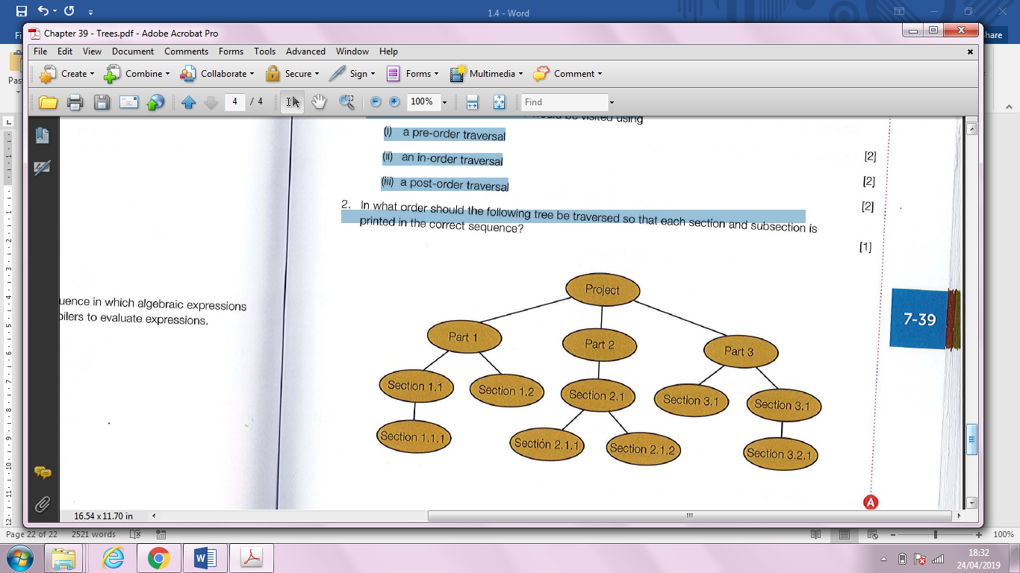

37. (a) Complete the following truth table for the XOR logic gate. (1)

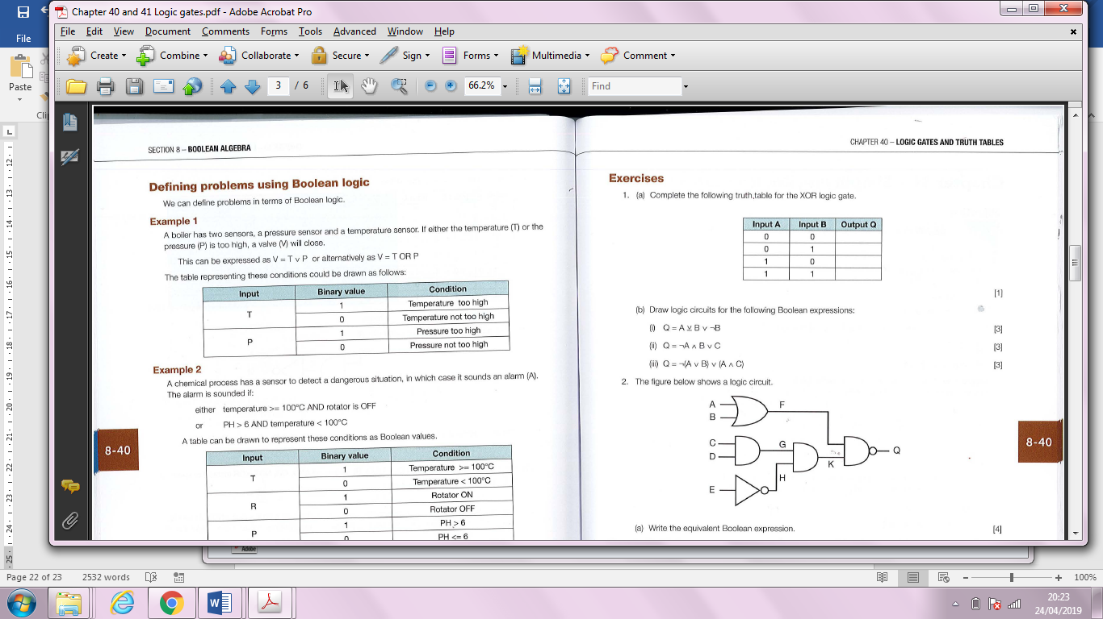

(b)Draw logic circuits for the following Boolean expressions:
(i) Q = A ⊻ B v ¬B (3)

(ii) Q = ¬A ∧ B ∨ C (3)

(iii) Q = ¬ (A v B) v (A ∧ C) (3)

38. The figure below shows a logic circuit.

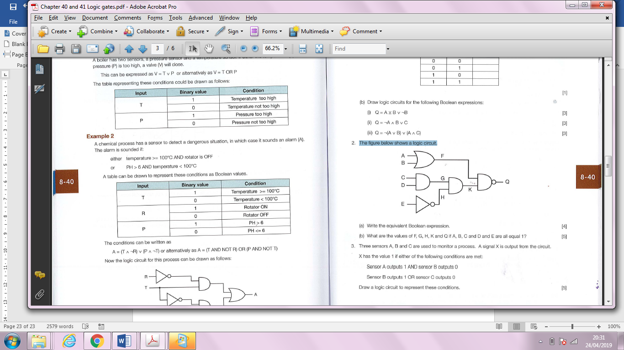

- Write the equivalent Boolean expression.

_______________________________________________________________

_______________________________________________________________

_______________________________________________________________

_____________________________________________________________(4)

- What are the values of F, G, H, K and Q if A, B, C and D and E are all equal 1?

_______________________________________________________________

_______________________________________________________________

_______________________________________________________________

_______________________________________________________________

_____________________________________________________________(5)

39. Three sensors A, Band C are used to monitor a process. A signal X is output from the circuit.
X has the value 1 if ei ther of the following conditions are met:
Sensor A outputs 1 AND sensor B outputs a
Sensor B outputs 1 OR sensor C outputs a
Draw a logic circuit to represent these conditions. (5)

Figure 1

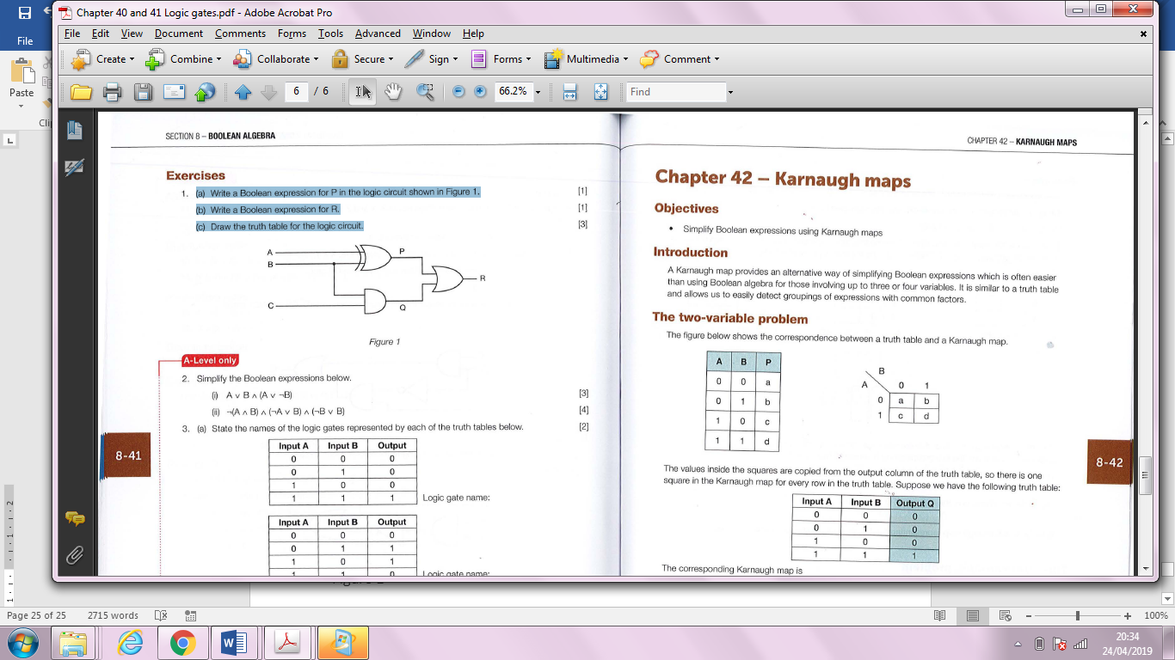

40. (a) Write a Boolean expression for P in the logic circuit shown in Figure 1.

_____________________________________________________________(1)

(b) Write a Boolean expression for R.

_____________________________________________________________(1)

(c) Draw the truth table for the logic circuit. (3)

41. Simplify the Boolean expressions below.

(i) A v B ∧ (A ∨ ¬B) (3)

(ii) ¬(A ∧ B) ∧ (¬A v B) ∧ (¬B v B) (4)

42. (a) State the names of the logic gates represented by each of the truth tables below. (2)

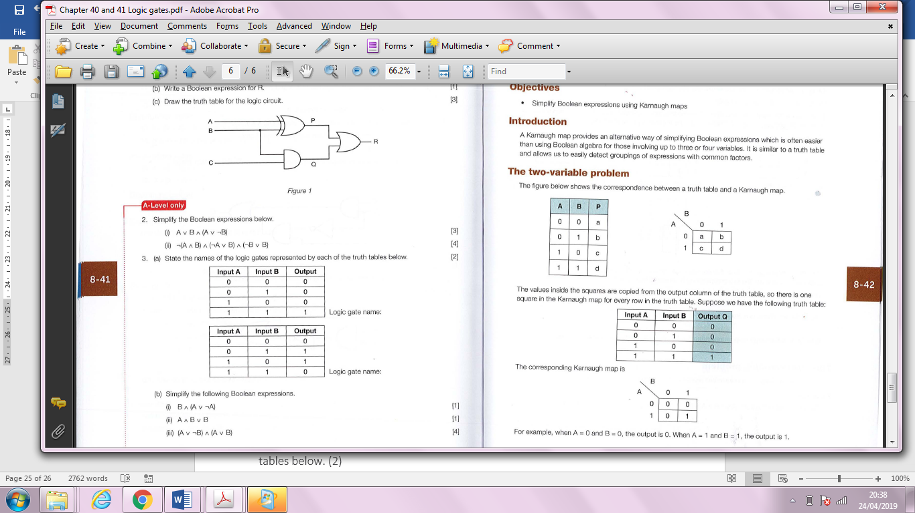
(b) Simplify the following Boolean expressions.
(i) B ∧ (A ∨ ¬A)

_____________________________________________________________(1)
(ii) A ∧ B ∨ B

_____________________________________________________________(1)
(iii) (A ∨ ¬B) ∧ (A ∨ B)

_______________________________________________________________

_______________________________________________________________

_______________________________________________________________

_____________________________________________________________(4)

(c) Draw a logic circuit for the following Boolean expression:
Q = A ∧ B ∨ ¬(A ∧ C) (3)

43. A Karnaugh map is shown below.

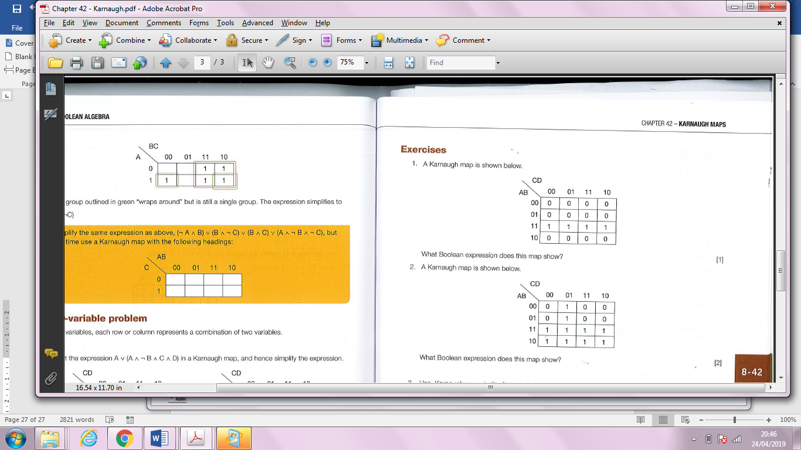
What Boolean expression does this map show?

_____________________________________________________________(1)

44. A Karnaugh map is shown below.
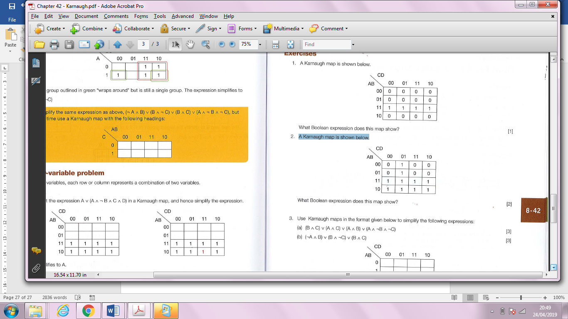
What Boolean expression does this map show?
_______________________________________________________________

_____________________________________________________________(2)

45. Use Karnaugh maps in the format given below to simplify the following expressions:
(a) (B ∧ C) ∨ (A ∧ C) ∨ (A ∧ B) ∨ (A ∧ ¬B ∧ ¬C) (3)

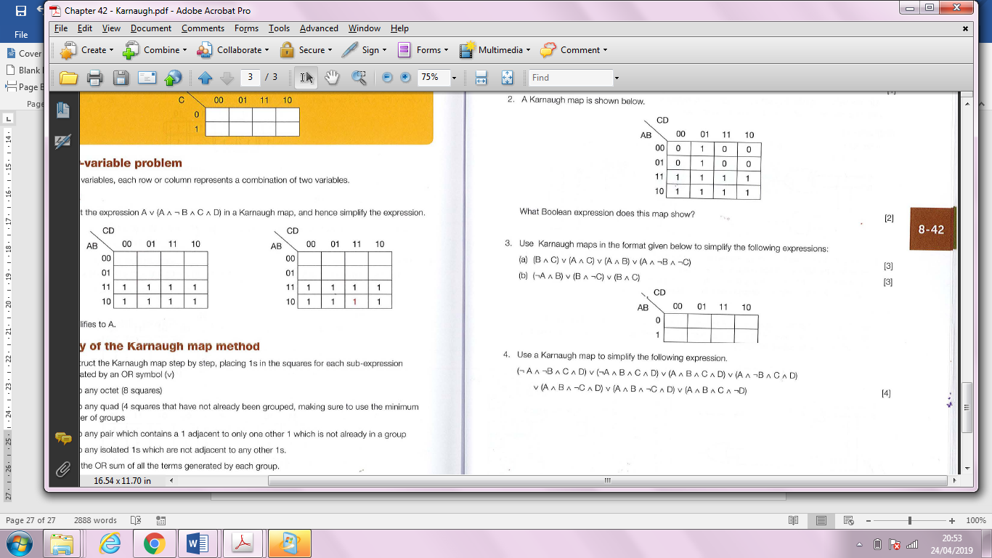

(b) (¬A ∧ B) ∨ (B ∧ ¬C) ∨ (B ∧ C) (3)

46. Use a Karnaugh map to simplify the following expression.
(¬A ∧ ¬B ∧ C ∧ D) ∨ (¬A ∧ B ∧ C ∧ D) ∨ (A ∧ B ∧ C ∧ D) ∨ (A ∧ ¬B ∧ C ∧ D)
∨ (A ∧ B ∧ ¬C ∧ D) ∨ (A ∧ B ∧ ¬C ∧ ¬D) ∨ (A ∧ B ∧ C ∧ ¬D) (4)

47. A half-adder is used to find the sum of the addition of two binary digits.
(a) Complete the diagram below to construct a half adder circuit. (3)
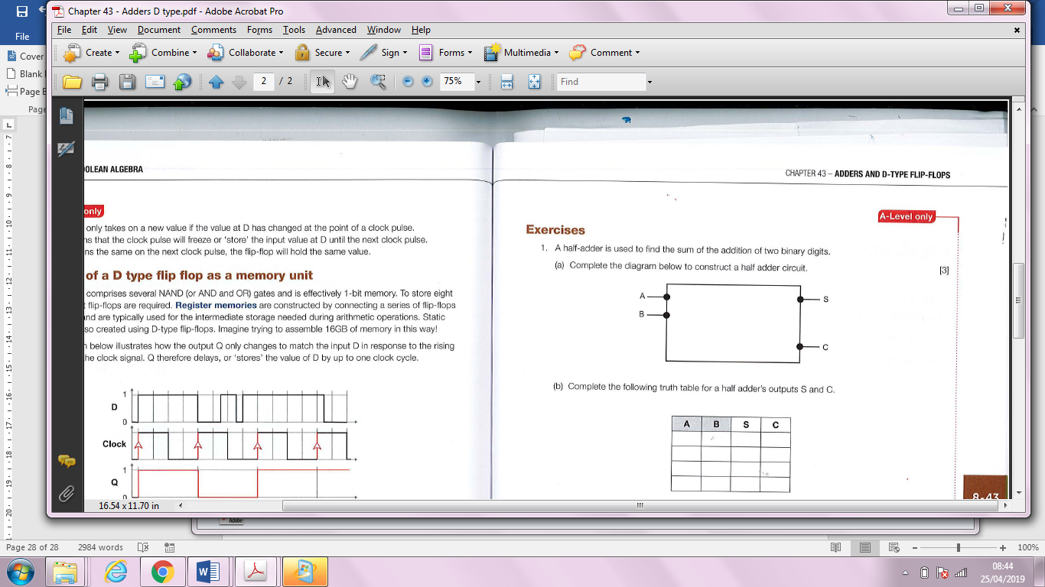

(b) Complete the following truth table for a half adder's outputs S and C.
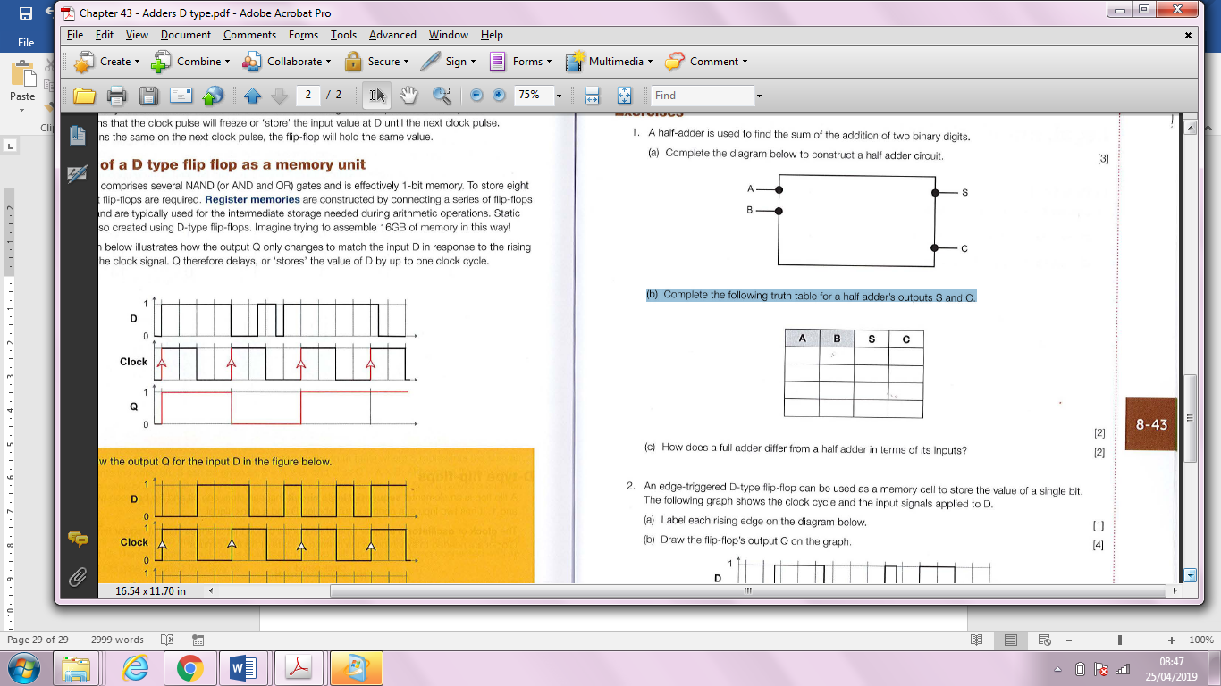
- How does a full adder differ from a half adder in terms of its inputs?
_______________________________________________________________

_____________________________________________________________(2)

48. An edge-triggered D-type flip-flop can be used as a memory cell to store the value of a single bit.
The following graph shows the clock cycle and the input Signals applied to D.
(a) Label each rising edge on the diagram below. (1)
(b) Draw the flip-flop's output Q on the graph. (4)

