|  |  |  |  |  |
| --- | --- | --- | --- | --- |
| **1.2 Software and software development** | | | | |
| Topic Area | Sub Topic | How I feel | | |
|  | | Red | Amber | Green |
| 1.2.1 Systems Software | The Arithmetic and Logic Unit; ALU, Control Unit and Registers (Program Counter; PC, Accumulator; ACC, Memory Address Register; MAR, Memory Data Register; MDR, Current Instruction Register; CIR). Buses: data, address and control: how this relates to assembly language programs. |  |  |  |
| Your notes | | |
| 1.1.1 Structure and function of the processor | The Fetch-Decode-Execute Cycle; including its effects on registers. |  |  |  |
| Your notes | | |
| 1.1.1 Structure and function of the processor | The factors affecting the performance of the CPU: clock speed, number of cores, cache. |  |  |  |
| Your notes | | |
| 1.1.1 Structure and function of the processor | The use of pipelining in a processor to improve efficiency. |  |  |  |
| Your notes | | |
| 1.1.1 Structure and function of the processor | Von Neumann, Harvard and contemporary processor architecture. |  |  |  |
| Your notes | | |
| 1.1.2 Types of processor | The differences between and uses of CISC and RISC processors. |  |  |  |
| Your notes | | |
| 1.1.2 Types of processor | GPUs and their uses (including those not related to graphics). |  |  |  |
| Your notes | | |
| 1.1.2 Types of processor | Multicore and Parallel systems. |  |  |  |
| Your notes | | |
| 1.1.3 Input, output and storage | How different input, output and storage devices can be applied to the solution of different problems. |  |  |  |
| Your notes | | |
| 1.1.3 Input, output and storage | The uses of magnetic, flash and optical storage devices. |  |  |  |
| Your notes | | |
| 1.1.3 Input, output and storage | RAM and ROM. |  |  |  |
| Your notes | | |
| 1.1.3 Input, output and storage | Virtual storage. |  |  |  |
| Your notes | | |

Exam Questions

1. (a) In the context of computer architecture, explain what is meant by the term bus.

_______________________________________________________________

_____________________________________________________________(2)

(b) Name three control lines used by the control bus.

_______________________________________________________________

_____________________________________________________________(3)

(c) What is the data bus used for?

_______________________________________________________________

_____________________________________________________________(2)

2. Describe the purpose of each of the following parts of a computer.

(i) Memory unit

_______________________________________________________________

_______________________________________________________________

_____________________________________________________________(3)

(ii) ALU

_______________________________________________________________

_______________________________________________________________

_____________________________________________________________(3)

3. The figure below shows an incomplete diagram of the components of a processor.

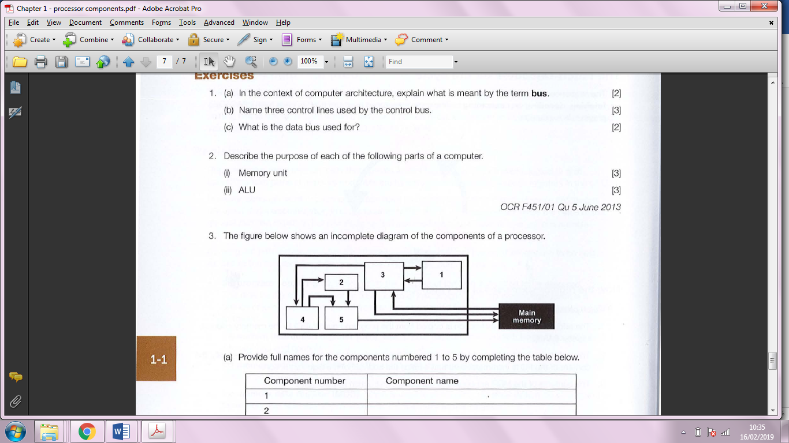

(a) Provide full names for the components numbered 1 to 5 by completing the table below.

|  |  |
| --- | --- |
| Component number | Component name |
| 1 |  |
| 2 |  |
| 3 |  |
| 4 |  |
| 5 |  |

(5)

(b) The figure below is an incomplete flowchart of the Fetch-Execute cycle.

Describe the missing steps.

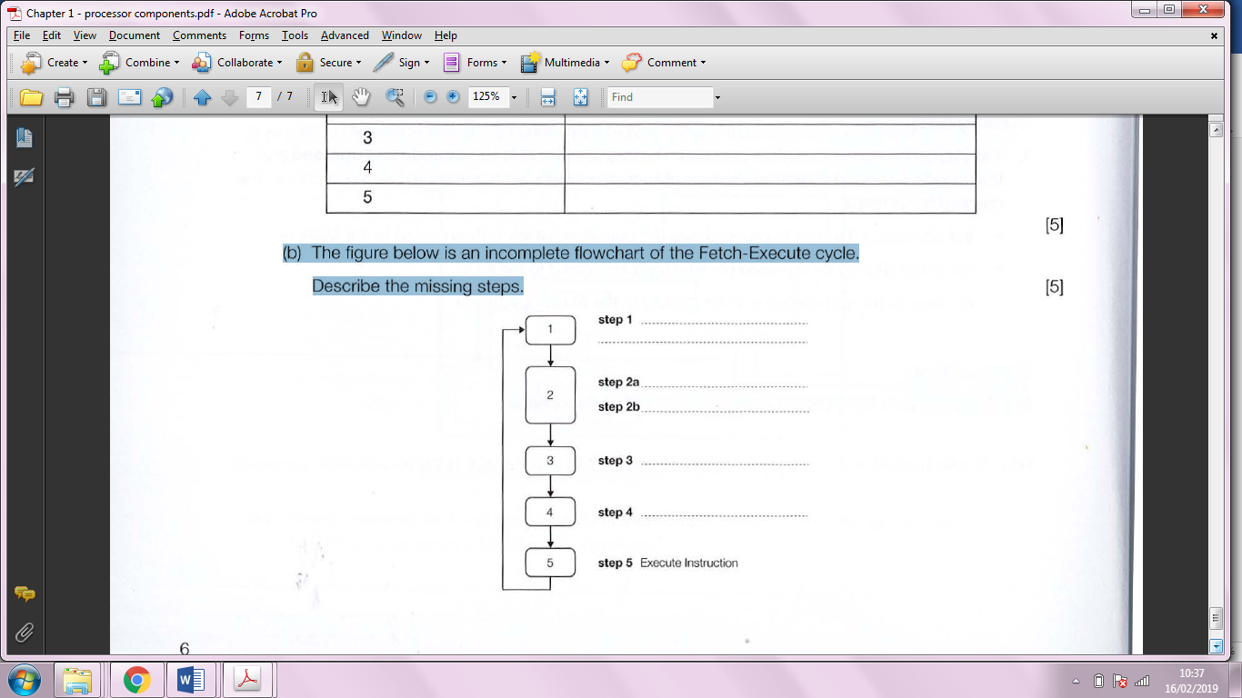

(5)

4. Name and briefly describe **three** of the main factors affecting processor performance.

_______________________________________________________________

_______________________________________________________________

_______________________________________________________________

_______________________________________________________________

_______________________________________________________________

_______________________________________________________________

_______________________________________________________________

_______________________________________________________________

_____________________________________________________________(9)

5. The program below is written in a low-level language.

AB2F; Load value 2F into accumulator

BD5D; Store contents of accumulator at address 5D

E402; Add value 2 to accumulator

BCFF; Store contents of accumulator at address FF

AC61; Load accumulator with contents of address 61

BC4A; Store contents of accumulator at address 4A

1. What is the name of the language?

_____________________________________________________________(1)

1. The machine for which this program is written has limited addressing capability.

What are the highest and lowest memory addresses that can be addressed by this machine?

_______________________________________________________________

_____________________________________________________________(2)

1. What is the width of the address bus in this machine?

_____________________________________________________________(1)

6. (a) (i) Give the name of the computer architecture that uses the fetch-execute cycle with a single control unit.

_____________________________________________________________(1)

(ii) Registers used during the fetch-execute cycle include the current instruction register (CIR), memory address register (MAR), memory data register (MDR) and program counter (PC).

Place ticks in the table to show which statements are correct during processing.

|  |  |  |  |
| --- | --- | --- | --- |
|  | CIR | MDR | PC |
| Holds a binary value |  |  |  |
| Always holds only an address |  |  |  |
| May change more than once during a single cycle |  |  |  |
| May pass a value to the MAR |  |  |  |

(b)(i) Compare a Complex Instruction Set Computer (CISC) architecture with a Reduced Set Computer (RISC) architecture.

_______________________________________________________________

_______________________________________________________________

_______________________________________________________________

_____________________________________________________________(4)

(ii) Explain one advantage, other than cost, of RISC compare with CISC.

_______________________________________________________________

_____________________________________________________________(2)

(c) Some computer systems use co-processors.

Explain the effect of using a co-processor system for each of the following applications.

1. Complex calculations of scientific research.

_______________________________________________________________

_____________________________________________________________(2)

(ii) Printing personalised letters to customers for an advertising campaign.

_______________________________________________________________

_____________________________________________________________(2)

7. Describe **three** different input devices that are used by police for crime detection and prevention.

_______________________________________________________________

_______________________________________________________________

_______________________________________________________________

_______________________________________________________________

_______________________________________________________________

_____________________________________________________________(6)

8. Describe **three** different input devices used at self-checkout in a supermarket, stating for what purpose each of them is used.

_______________________________________________________________

_______________________________________________________________

_______________________________________________________________

_______________________________________________________________

_______________________________________________________________

_____________________________________________________________(6)

9. Computer software is used in Geography Iessons to teach students about weather systems.

(a) (i) State the purpose of an input device in a computer system when using in this software.

_____________________________________________________________(1)

(ii) State the purpose of an output device in a computer system when using this software

_____________________________________________________________(1)

(b) Describe how the following forms of output will be used by the software. .

(i) Animation

_______________________________________________________________

_____________________________________________________________(2)

(ii) Interactive presentation

_______________________________________________________________

_____________________________________________________________(2)

10. State, with reasons, what type of printer you would recommend for the following applications:

(a) Invoice/delivery note printed on 3-part paper with 2 carbon copies.

_______________________________________________________________

_______________________________________________________________

_____________________________________________________________(3)

(b) Flyers produced by a small window-cleaning business to be delivered to all homes in a particular area.

_______________________________________________________________

_______________________________________________________________

_____________________________________________________________(3)

(c) Producing high-quality prints of a set of photographs.

_______________________________________________________________

_______________________________________________________________

_____________________________________________________________(3)

11. What type of screen would you recommend for an in-flight entertainment system? Give reasons for your choice.

_______________________________________________________________

_______________________________________________________________

_______________________________________________________________

_______________________________________________________________

_____________________________________________________________(5)

12. (a) Describe how data is written to and read from a CD-R disk.

_______________________________________________________________

_____________________________________________________________(2)

(b) A school has archived all its students' reports on to CD-R. Some years later, a copy of a particular student's reports is requested. Unfortunately it is found that the documents cannot be opened.

Give **two** reasons why this may be the case.

_______________________________________________________________

_____________________________________________________________(2)

2. If you are considering purchasing a high-end desktop or laptop you might be offered the option of a solid-state drive (SSD) rather than a traditional hard disk drive.

(a) Describe briefly how a solid-state drive differs from a hard disk in its operation.

_______________________________________________________________

_______________________________________________________________

_______________________________________________________________

_______________________________________________________________

_____________________________________________________________(6)

(b) Ignoring any differences in price and assuming that both drives have the same capacity, state four reasons why you might choose the solid-state drive.

_______________________________________________________________

_______________________________________________________________

_______________________________________________________________

_____________________________________________________________(4)