Web Technologies - JavaScript

**Introduction**

So far we have looked at HTML and CSS. We have seen how HTML gives a webpage structure and CSS code can improve the presentation of a webpage.

Both HTML and CSS are great at adding basic page content and making it look good…

…however, neither really allow a user to interact with the page or enable the page to possess features such as small applications which could process inputted data.

We shall now take a look at the JavaScript scripting language and see how to code some simple scripts.

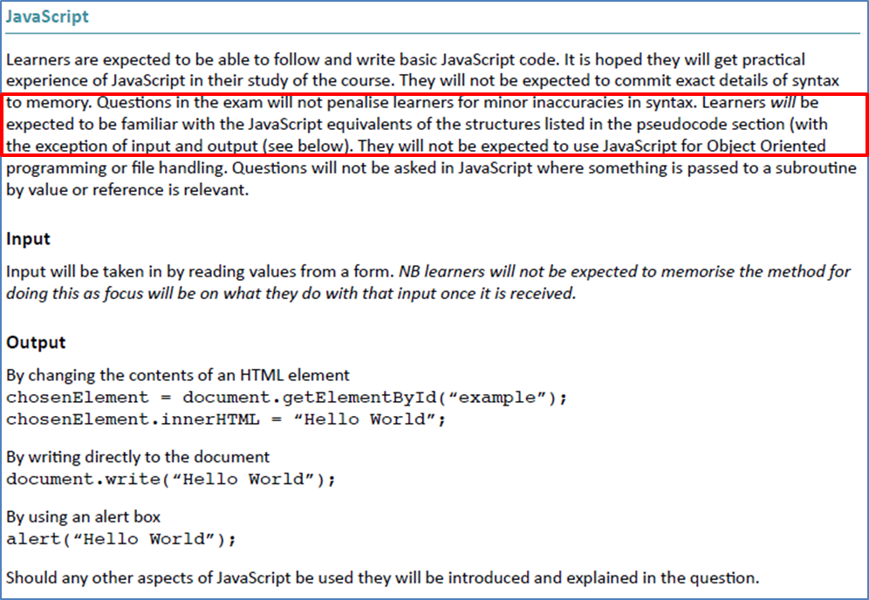**What you need to know – Java Script**

Here is a list of JavaScript code that you are expected to understand for your exam.

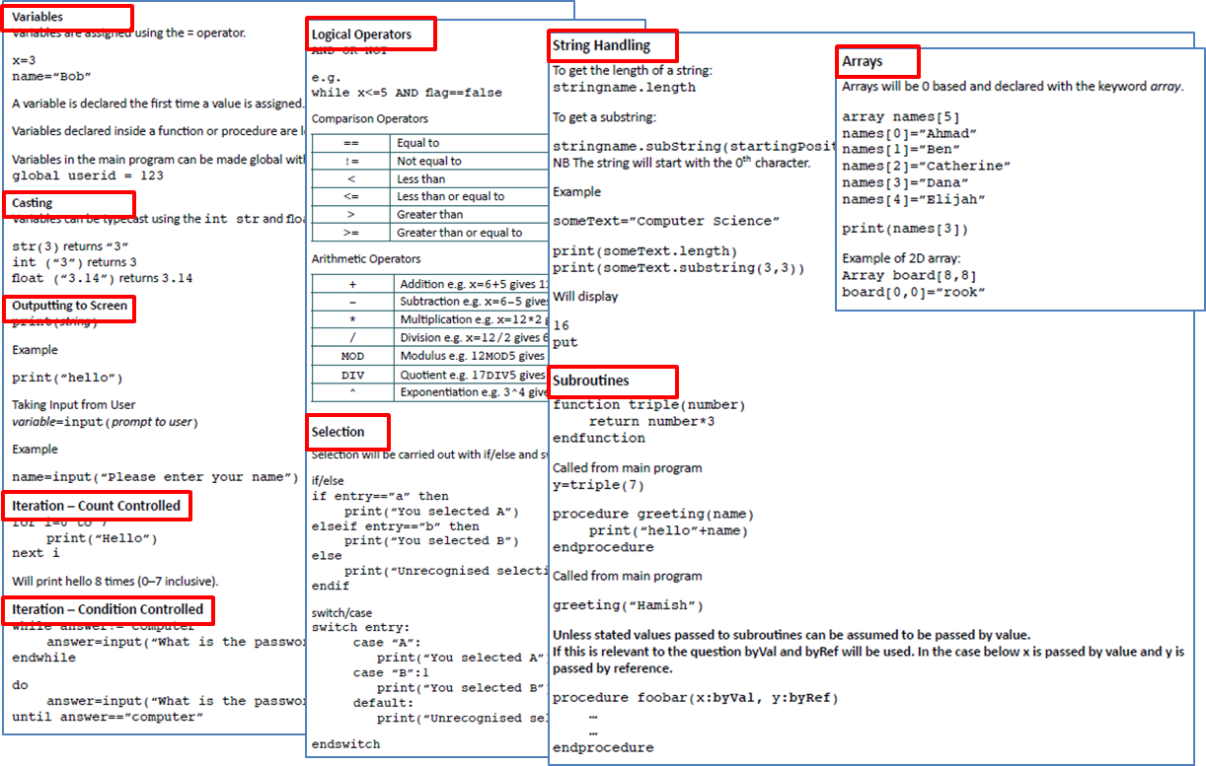

***Outputs***

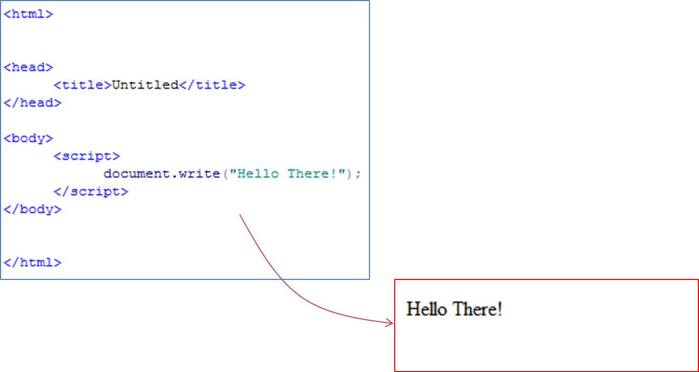

Here is an example of adding a single line of JavaScript into a webpage.

Notice how it is placed between <script> tags. This is so the browser knows to read it as JavaScript.

This code simply outputs ‘Hello There!’ onto the screen

***Variables***

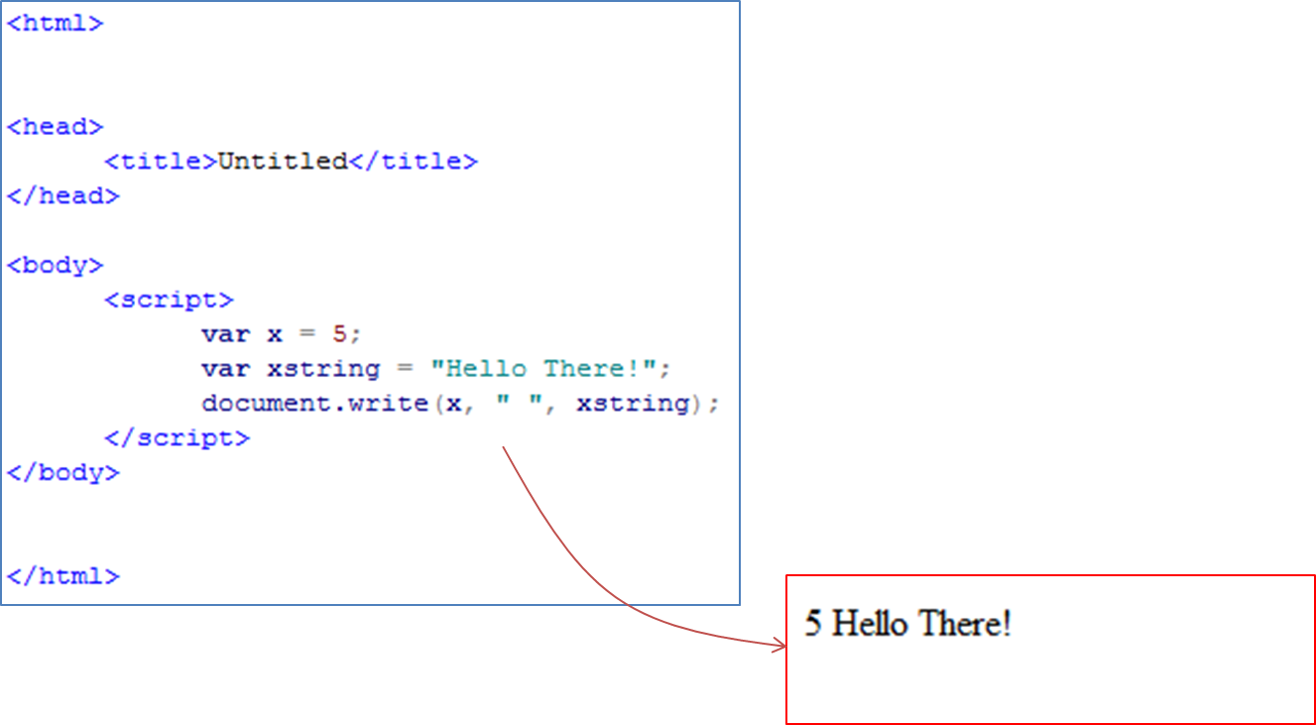

Like other programming languages, variables can be declared and assigned values in order for the program to store different data items.

This is an example of storing to pieces of data in two separate variables and then outputting them onto the screen.

***Alert Box***

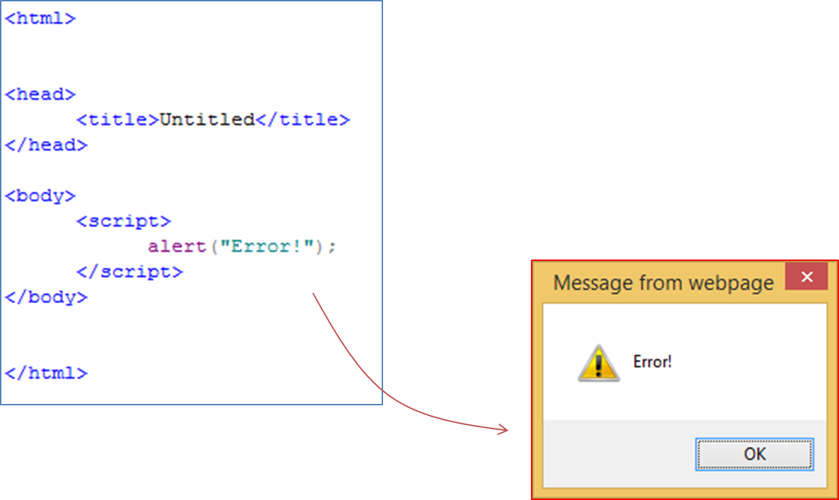We have already seen how data can be outputted on the webpage using the ‘document.write()’ statement.

We can also output messages in an alert box (pop up window).

Here is an example.

***FOR Loops***

Like other programming languages, a set of collected data can be stored together under one identifier in a data structure called an array.

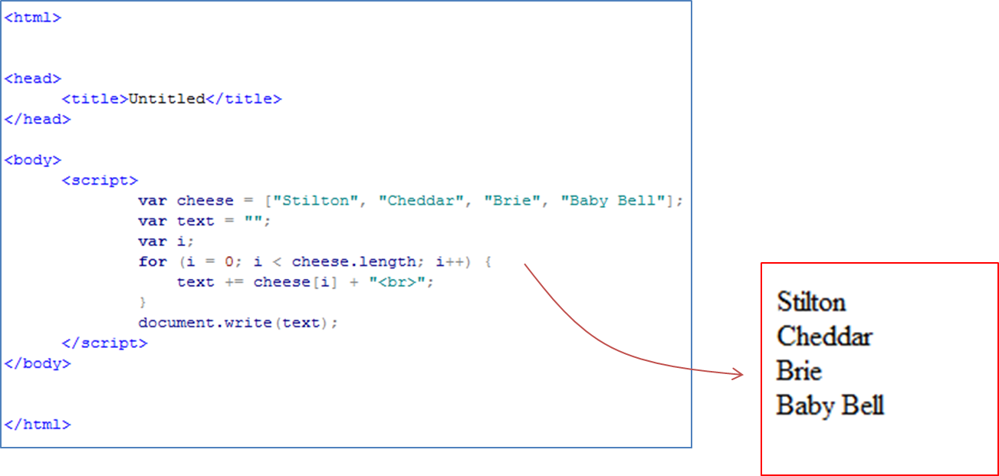Furthermore, FOR loops can be implemented to repeat lines of code for a set number of times.

This is an example of storing a set of data in an array and then looping through array, outputting each item on the webpage.

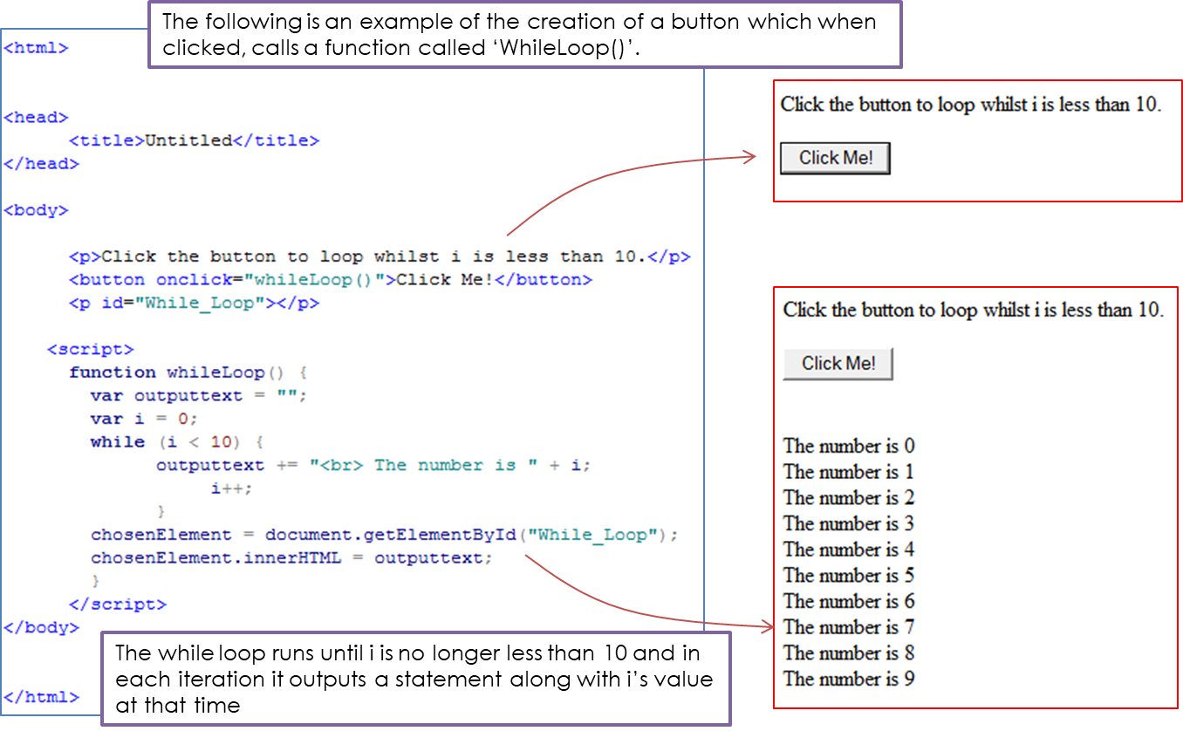***WHILE Loops***

***Selection***

Like other programming languages, JavaScript makes use of selection statements (IF statements) so that different lines of code can be executed depending on a given condition.

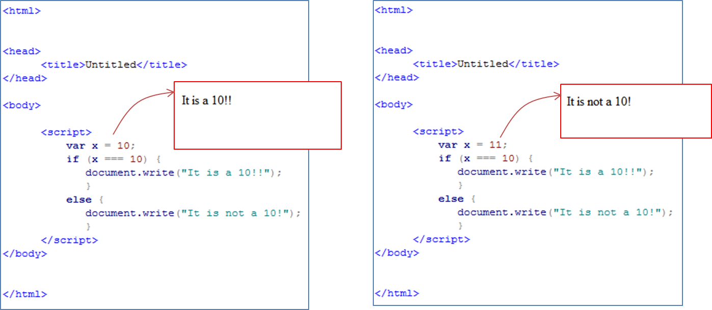Below is an example of how JS selection statements are structured / written.

***CASE Statements***

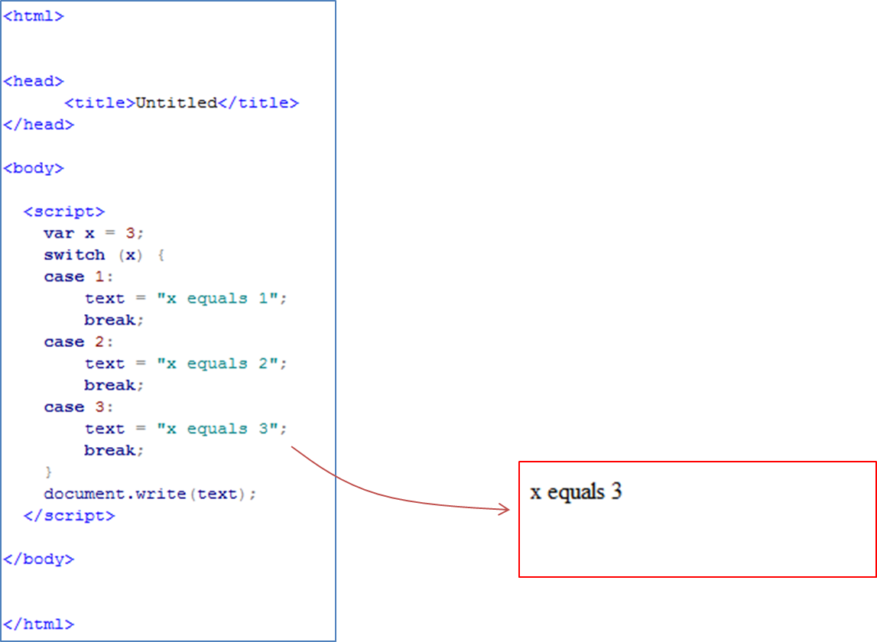

If more than two possible lines of code are to be run depending on the condition, JS enables the use of ‘Case Statements’

Below is an example of how JS case statements are structured / written allowing different instructions to be executed depending on the given condition.

***String Methods***

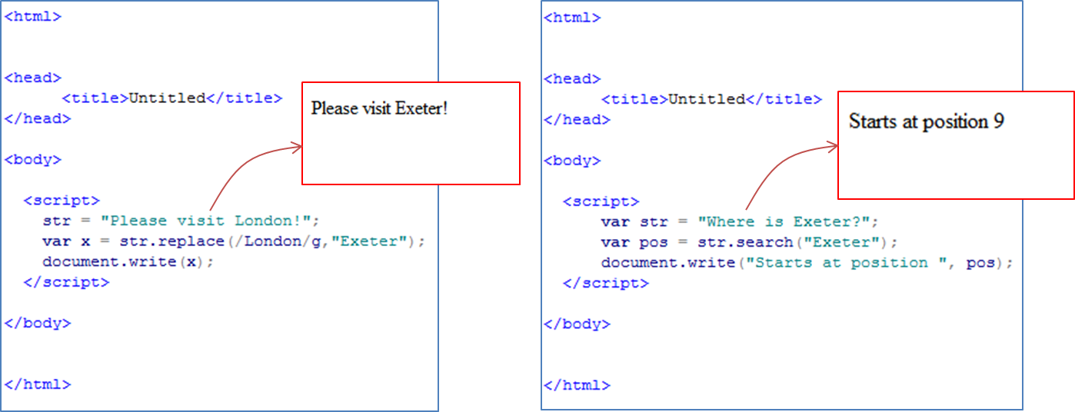JavaScript also supports a range of string manipulation methods. Below is an example of two. The first shows how an substring within a string can be replaced with another substring. The second shows how you can find the position of a given substring within a string.

***Functions***

It is possible to write functions in a JavaScript script.

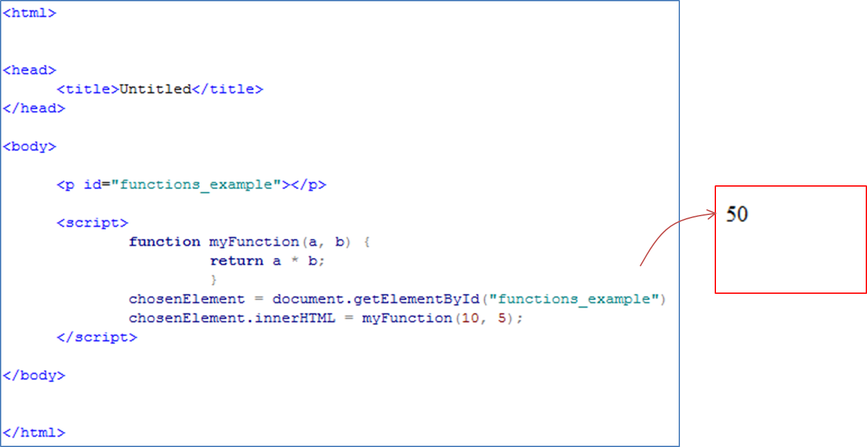Below is an example of how a function can be declared and how it can be later called, passing values into it and receiving the functions ‘returned items’, outputting it directly into a paragraph tag on the webpage.

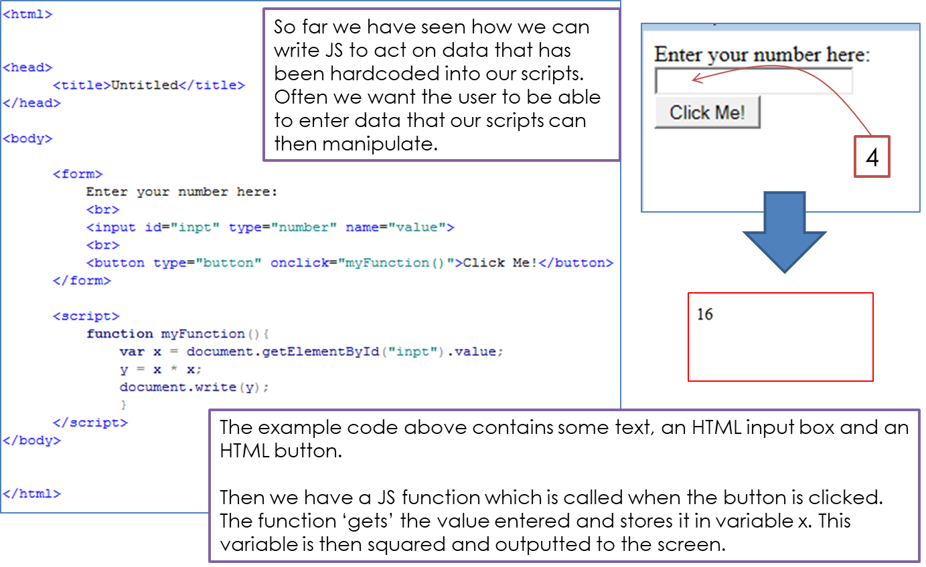***Inputs***