The Internet, the WWW and Virtual Networks

**Introduction**

In this workbook we will take a look at:

* What the internet is,
* How it differs from the World Wide Web,
* What a web host is,
* How DNS works,
* What the Cloud is,
* How virtual networks can be formed using internet technology.

**What is the Internet?**

The Internet is the biggest WAN in the world. The internet is a massive network of networks. In other words, it is a ginormous collection of connected computers.

**Is the Internet and the World Wide Web the same?**

Although these two terms are used interchangeably, they are in fact very different. As explained above, the Internet is a ginormous collection of connected computers. The World Wide Web however, is just one application / use of the Internet. The WWW is the web of websites, providing the sharing of information. Other applications of the Internet are E-mail and FTP downloading.

**Web Hosting**

A host is a computer on a network which offers to serve users from another location, using the internet. Web hosting, in particular, is a service provided by various companies. These companies ‘host’ websites on their servers so that people around the world can access them 24/7. They will often charge a small fee for the rental of hard drive space, site security and back up services. It is of course possible for anyone (with a little knowhow) to host their own websites on their home PC, but for the price and risk, it is often more cost effective and less risky to pay for a specialist company to do this for you.

**Web Hosting and DNS**

In order to connect to various webhosts, so that we can access the websites we need, we use a system called DNS. In order to understand how DNS works we first need to understand a few other important acronyms.

**IP Address**

This means INTERNET PROTOCAL ADDRESS. It is a unique number given to every computer on the internet – no two computers can have the same address (e.g. 324.45.321.23). It’s just like a postal address – used to identify a house – no two houses have the same address! A device’s IP address will not necessarily remain the same each time it joins a network or goes on-line.

**ISP**

This means INTERNET SERVICE PROVIDER. This is simply the company who provide you with your internet connection.

**URL**

This means UNIFORM RESOURCE LOCATOR. This is simply a fancy name for a web address, such as “http://www.bbc.co.uk” or “http://www.google.com”.

**DNS**

This means DOMAIN NAME SYSTEM. This is the system used to find the computer which hosts the website you are looking for.

***How does DNS work?***

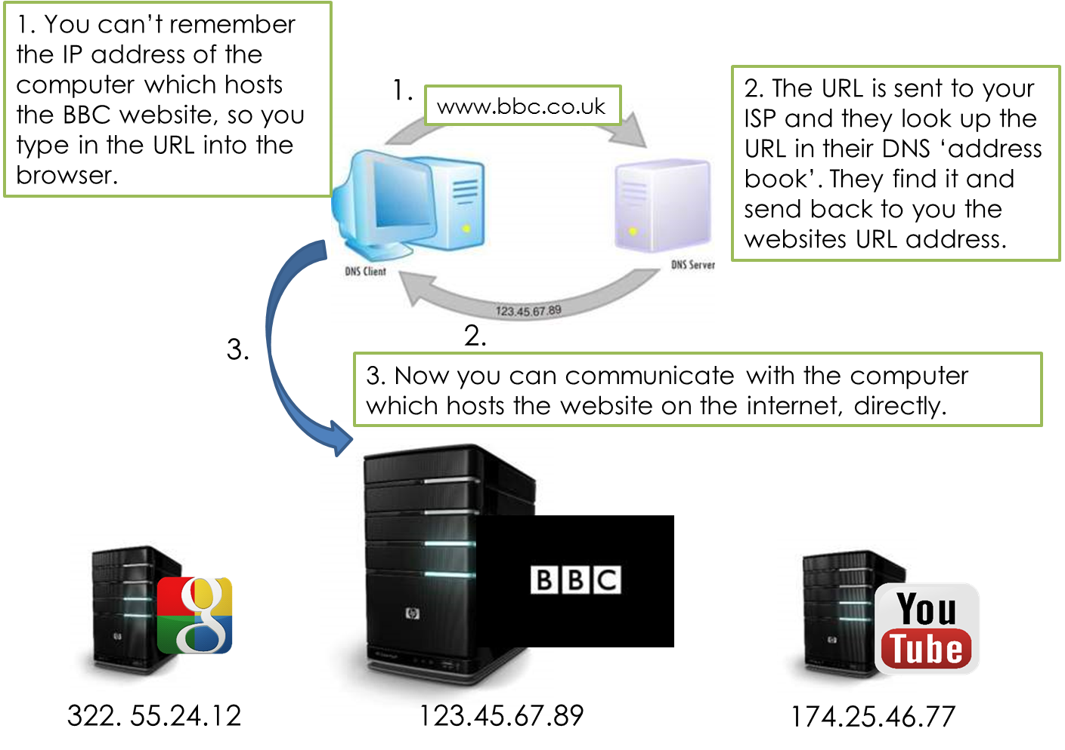

**The Cloud**

‘The Cloud’ is a network of servers hosted on the internet which offer a range of services to store and process data. In particular, ‘Cloud Computing’ relates to online services provided by numerous companies.

Examples of cloud computing are:

* Office 365 / GoogleDocs
* Cloud Storage (GoogleDrive, OneDrive, DropBox)
* Netflix / Spotify

***Why would a company use such a service as office365?***

* They do not need to ‘buy’ and install the software.
* Any ‘connected’ computer can access the service.
* There is no need to upgrade the software.
* Collaboration can occur with multiple people working on the same document at once.
* Work is automatically saved / backed up.

This generally all leads to lower costs.

But…

* Sensitive company data may be stored in another country which may not adhere to the same data laws as the country the company is in.
* Completely reliant on the network / internet.

**Virtual Networks**

We should by now be happy with the idea that LANs are a network of computers over a small geographical location and WANs are a network of computers over a wider geographical area. For both types of network, they are created through the connection of physical hardware.

A virtual network is one which uses software to subdivide a physical network (LAN or WAN) into smaller ones.

***Virtual Networks and LANs (VLANs)/***

For a simple virtual network, software will re-divide a LOCAL AREA NETWORK into a series of smaller networks so that (for example) groups of workers can communicate and share information separately from other members of a company. Because it is software which enables the network to partitions (hardware remains as it was) it is knows as a VIRTUAL network.

***Virtual Private Networks (VPN) and WANs***

Software can also re-divide a WIDE AREA NETWORK into a series of smaller networks so that (for example) groups of workers spread across the country / world can communicate and share information separately from other members of a company. As the internet is used by all, these networks will need added security and this is done through encryption. Due to this they are given the name PRIVATE NETWORKS, but of course, because they are created through the use of software, they are known as Virtual Private Networks (VPN).

***Keywords / Key Terms:***

DNS - Domain Name System – a system to look up URLs in exchange for an IP address.

The Cloud - A term given to describe a network of servers hosted on the internet which offer a range of services to store and process data.