Server and Client Side Processing

**Introduction**

*What is a Webserver?*

A webserver is a computer with specialised software which hosts sites and delivers webpages to users.

When you visit a website online, you are really just communicating with a computer which hosts the website and you request pages to be sent to your browser so that you can interact with its content. A popular website might have thousands of visitors every second and so webservers need to be able to process all of these users requests efficiently.

This could put a lot of strain on a webserver if it doesn’t have the appropriate resources (processing power). Ever heard of a website doing down when under high demand?!

In this workbook we will take a look at two ways in which webpage requests and other related tasks can be handled to ensure both efficiency and security.

**Server and Client Side Processing**

When you communicate with a webserver, your computer is classed as the ‘Client’ and the webserver is of course the ‘Server’

**Server Side Processing**

When you browse a website, purchase an item online, make a booking etc. the webserver will carry out a fair deal of processing.

For example, if you sign in to a website, the website itself will need to validate that you are who you say you are and so will collect your username and password and check that it authenticates with the information stored on their database.

This is known as ‘server side processing’. The server itself carries out the processing. This is clearly vital in this situation for security reasons.

**Client Side Processing**

There are however times that processing doesn’t need to be carried out by the webserver and in order to reduce the stress put on the server, a well written website will always try to push as much processing towards the client (where possible).

For example, if you were to enter an email address when signing up to a website (for example) it is not a security risk if the email address is not validated by the server. In examples like this the webpage will contain some JavaScript allowing the client itself to validate that an email address is entered in the correct format. This is known as ‘client side processing’.

Client side processing may also occur if the client has specialised software required to carryout a process.

Either way, getting to client to carryout the process means reduced data transfer from server to client thus can improve the speed of ones online experience.

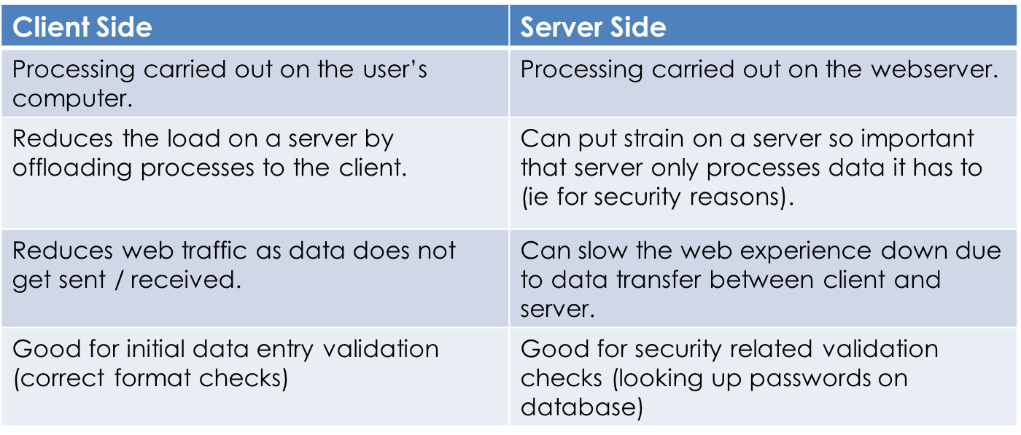**The Main Differences…**