The Operating System

The operating system is the most important piece of software on any computer. Without it, no programs will run. This is because an operating system is responsible for controlling / communicating with the computer hardware. It provides a platform on which games, browsers, music players etc, can all work.

***WHY?***

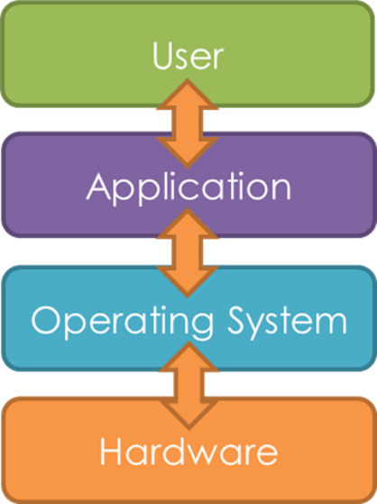If you were to run an everyday program (e.g. a word processor), without an operating system, nothing would be displayed on the screen, nothing could be sent to the printer, nothing could be typed. This is because application software, does not know how to TALK to hardware devices. However, the operating system does. The operating system can also talk to the application that is running.

So when you print a document, the application talks to the OS, which in turn talks to the printer. The operating system sits between the user’s applications and the hardware. It enables applications to use the hardware resources.

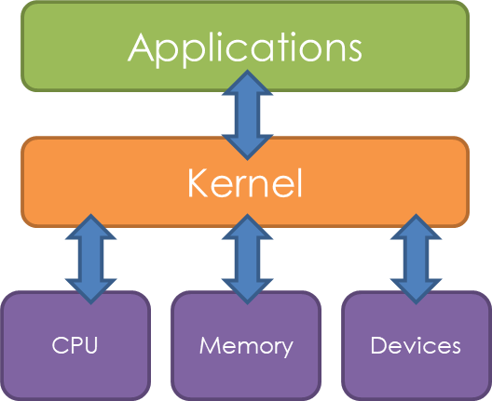**The Kernel**

The kernel is the heart of the operating system and is responsible for looking after “the most low-level hardware operations”.

It is the kernel that applications make use of when they want to operate the computer’s hardware.

**Function and Purpose**

We have already seen how operating systems provide an interface for users and how the operating system can bridge the gap between software and hardware so both can communicate with one another.

However there are further services that operating systems provide. The following is a formalised list of the main functions of an operating system:

* Interface
* Memory Management (paging, segmentation and virtual memory)
* Peripheral Management (BIOS and Device Drivers)
* Multi-Tasking (interrupts, the interrupt service routine and scheduling)

*(These will each be looked at in more detail in the next topic workbook).*

**Types of Operating System**

There are several types of operating system, which although all provide the functions outlined on the previous slide, are tailored to meet the requirements of a variety of different situations.

Several types of operating system are listed below and later explained in more detail:

* Distributed OS
* Embedded OS
* Multi-tasking OS
* Multi-User OS
* Real-time OS

**Distributed Operating Systems**

A distributed operating system ‘sits in front of’ and controls a host of different computers which may be connected across a LAN or a series of LANs. This is clearly quite different from the operating systems that we may be used to, which are installed on individual computers.

They are designed to spread different tasks across a range of computers to make use of their combined processing power so that greater performance is achieved. The operating system coordinates and controls the processing of all the computers involved.

To a user it would appear as if they are using a single computer but behind the scenes the operating system is making use of a great deal of different resources to provide a much more powerful system.

**Embedded Operating System**

An embedded system is one that is designed for a single device which may just have a small number of jobs to perform. Devices such as TVs, mobile phones and dishwashers are all devices which will be control by an embedded system. Embedded operating systems are a type of operating system, which control embedded systems. They are likely to be customised for the device on which they are installed, so that they best harness the resources of the hardware to ensure the device is optimised for the best performance.

**Multi-Tasking Operating System**

A multi-tasking operating system is the kind that you might find on a home PC. The home PC is likely to have multiple programs open at the same time and therefore millions of processes needing to be executed from different programs in the same space of time. Because home PCs are likely to have a limited number of CPU cores, they will not be able to execute all of these processes at once. Instead, they are executed in quick succession with each program taking it in turns to have their tasks processed. A multi-tasking operating system is specifically designed to enable the management of these processes so the CPU can be given the right tasks at the right time to make it appear that all of the programs are running quickly and simultaneously.

**Multi-User Operating System**

A multi-user operating system is one which is designed to enable several users to all access a systems resources at the same time. Your home PC, although may have different accounts for your family members, will not allow two people to be logged on at once and so is not considered a multi-user operating system. These specialised operating systems are likely to be found on mainframe computers.

**Real-Time Operating System**

These types of operating systems are specially designed to perform tasks within a definitive time-period. Consider a system controlling a nuclear power station. Any issues will need to be detected and addressed with immediate effect to ensure the system continues to run safely. Aeroplane systems will also need to respond to events such as turbulence, within a fraction of second, to ensure the safety of the flight. Real-time operating systems are optimised to process priority jobs incredibly quickly. They will also have ‘fail-safe’ features so that in the event of a piece of hardware failing there is another component that can quickly be used.

**Questions**

**‘General Understanding’ Questions**

1. Explain what the kernel is in relation to operating systems. [2]
2. Explain (using examples) the role of an operating system in terms of its relationship with the user and the computer hardware. [4]
3. State the 4 functions of an operating system. [4]
4. List the 5 type of operating system and for each one, explain (using examples) their main features. [15]