We recommend using Peter Higginson’s version of LMC. Although written for the GCSE specification, it includes a number of useful additions such as comments and blank lines that make it slightly easier to use, without compromising the RISC instruction set.

<http://peterhigginson.co.uk/LMC/>

There is a downloadable version too.

Annotated example program:

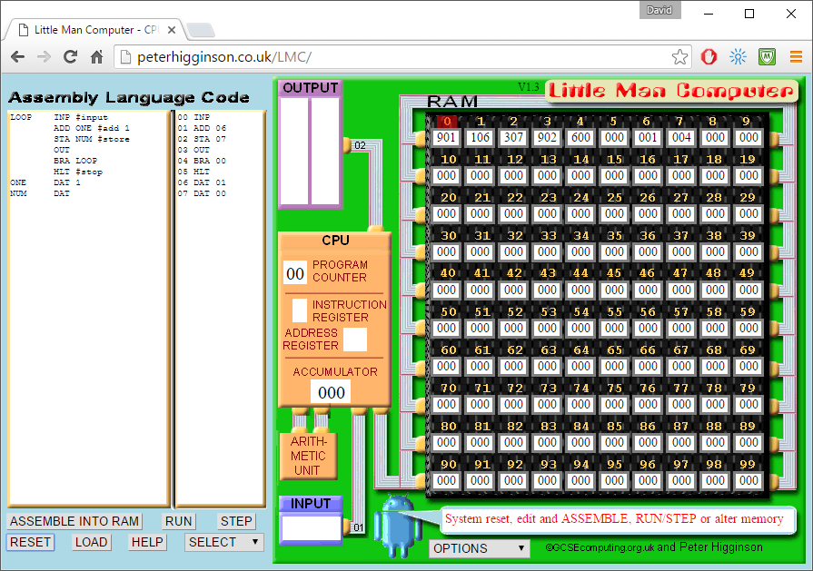

6. Click reset to clear registers.

5. If an input is required, enter here.

4. Click RUN to run program.

3. Assembled code appears here.

1. Enter your code in this window.  
Tabs/spaces are automatic.

2. Click assemble into RAM to load program.

Points to note in this version of LMC:

Loop entry points are indicated with labels before the command, e.g.  
 LOOP INP (loop label and input command)  
 BRA LOOP (branch to loop label)

Comments can be entered with a # symbol at the end of a command.

Blank lines are supported to split up sections of the program.

DAT is used to declare a variable and can be used as a constant if given a value.