Web Technologies - CSS

**Introduction**

We have already looked at HTML and how it enables text and images to be placed on a webpage.

The biggest issue with HTML is that although it is good at getting basic content on a page and giving a page some structure, it doesn’t allow for easy and professional formatting.

CSS code is another language which can be applied when writing webpages to improve the presentation of a webpage.

***HTML…the structural layer***

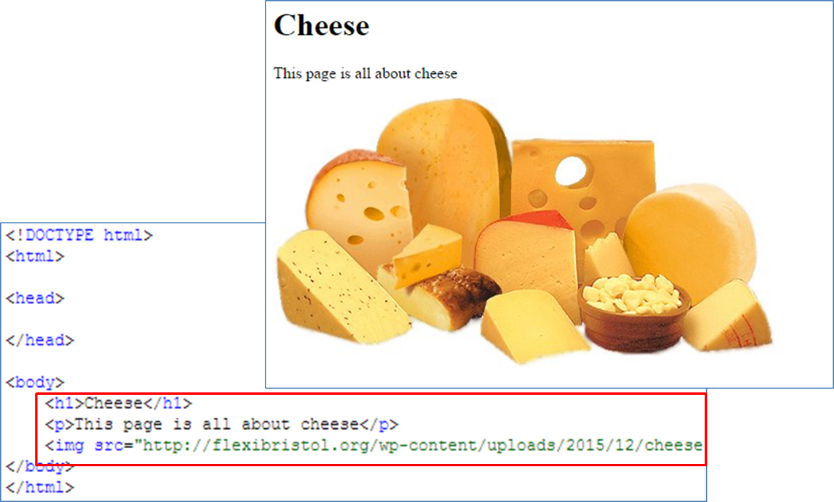“Code which tells the browser how text and images should be structured on the screen”

***CSS…the presentation layer***

“Code which tells the browser how text and images should be presented on the screen”

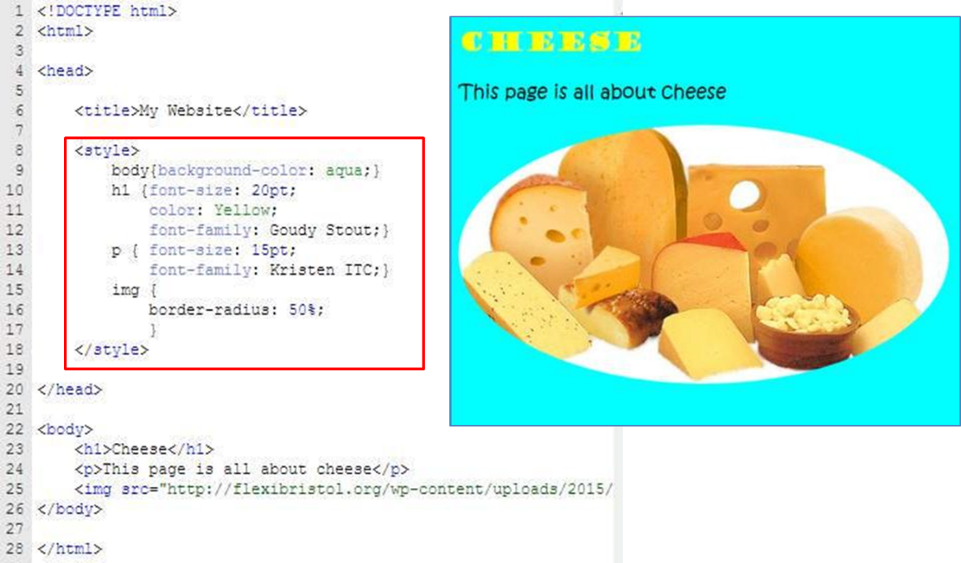

So here you can quite easily see how a few lines of CSS can completely change the look of a webpage which has exactly the same HTML.

**How do we insert CSS?**

There are 3 ways to insert CSS:

1. External style sheet
2. Internal style sheet
3. 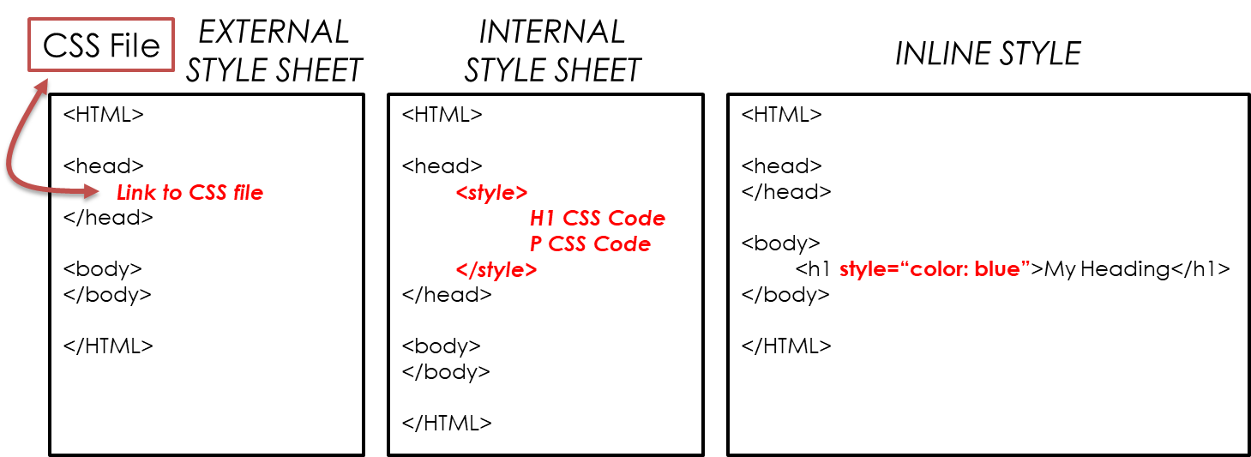Inline style

**External style sheet**

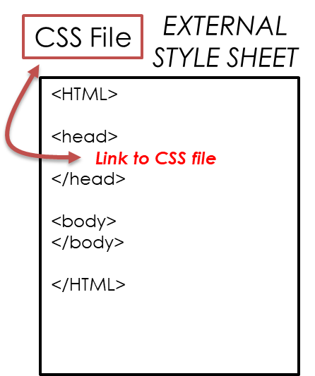

This is where all of the CSS code is stored in a separate file.

A link to this file is made from the HTML page.

The browser will style the HTML based on the CSS code stored in this external file.

**Internal style sheet**

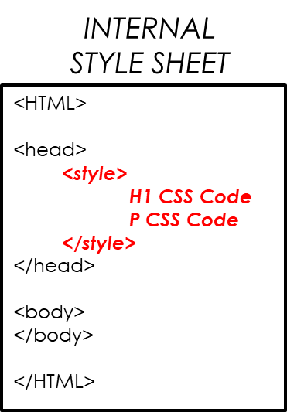

This is where all of the CSS code is stored together on the HTML page itself.

The CSS is stored inside <style> tags.

The browser will style the HTML based on the CSS code positioned between the <Style> tags.

**Inline style**

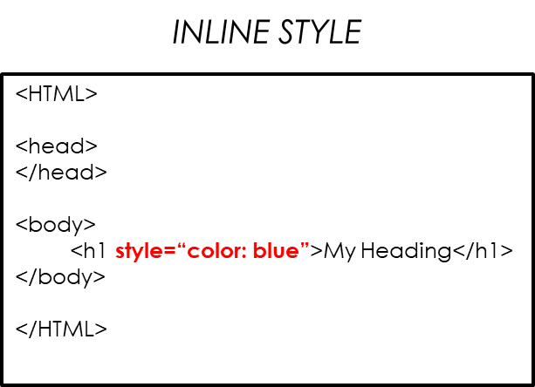

This is where CSS code is added to individual pieces of HTML code.

It therefore styles only the HTML in which it is written.

The browser will style the individual HTML items based on the CSS code that accompanies it.

**What you need to know - CSS**

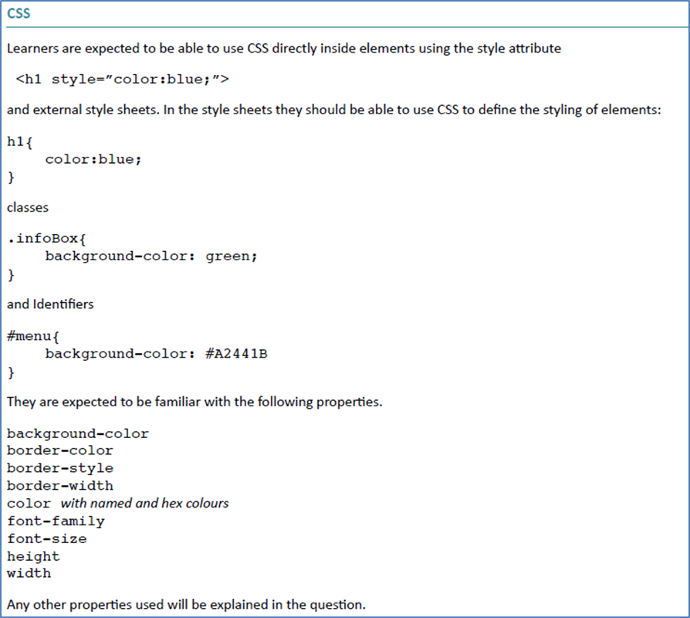

Here is a list of CSS code that you are expected to understand for your exam.

The following section demonstrates the application and result of many of these items of code.

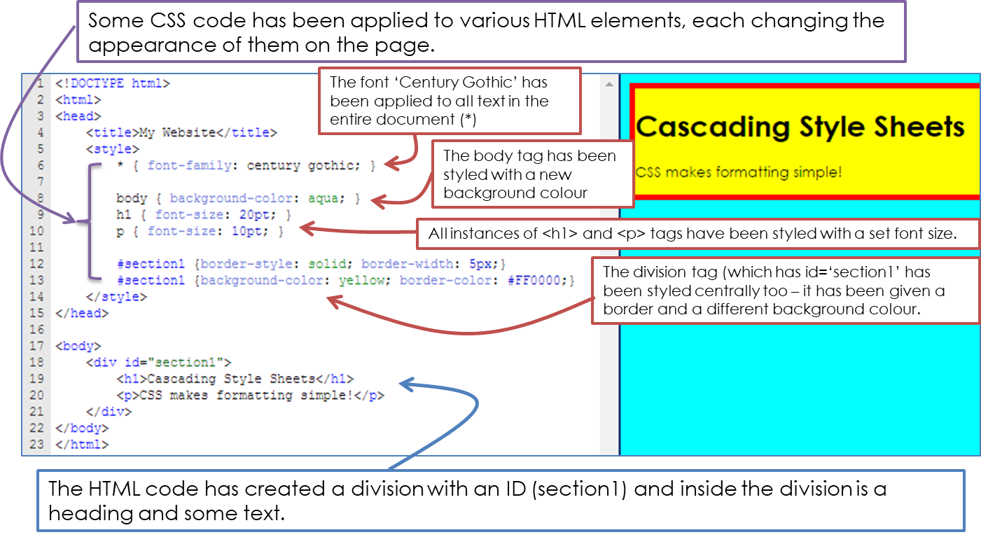

**Questions**

**‘Application and Challenge’ Class Activity**

Create a simple webpage in HTML which also contains CSS code to improve the appearance of the page. [10]

Your page must include at least 2 divisions and in each division there needs to be:

HTML content:

<h1>

<p>

<img>

A range of CSS formatting on each of these HTML elements.

CSS formatting of the background and borders of each division.

**‘General Understanding’ Questions**

1. Explain, using examples, the different ways that CSS can be applied to a webpage [6].
2. For the given HTML code, write the CSS code that would style:

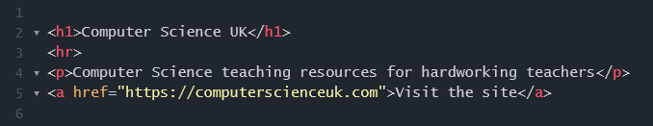

* 1. the heading so that its font size is 12 and its text colour is red [2]
  2. style all text in the document so that its font is Arial.[1]

1. How can one identify different ‘divisions’ in an html document and style each division differently using CSS code? (provide an example to demonstrate this).[4]