Network Types and Network Hardware

**What is a network?**

A network can be defined as “two or more computers connected together to share information and resources”. This can involve physical or wireless connections, or both.

**Local Area Networks**

**What is a LAN?**

A LAN is a Local Area Network. It is a connection of computers and devices which are confined to a small geographical area. They are therefore relatively small and quite often the network infrastructure will be the property of the organisation.

Top fact: Each device on a network is known as a **node** (e.g. computer, printer, etc.)!

**Advantages of Local Area Networks**

They enable:

* Digital communication between people
* The sharing of digital information
* The sharing of peripheral devices such as printers and scanners
* Computers to be updated with the latest software from a central point
* Distributed processing – the ability for a single program to be run simultaneously at various computers.

**Disadvantages of Local Area Networks**

* They require a bit of ‘expertise’ to install and maintain a large network which can be costly.
* There are a number of security issues from unauthorised access to data.

*Measures to secure a network include:*

* Passwords – strong passwords use a range of character types
* Not allowing users to install software
* With wireless access, use encryption
* Changing passwords frequently

**What is needed to make a LAN?**

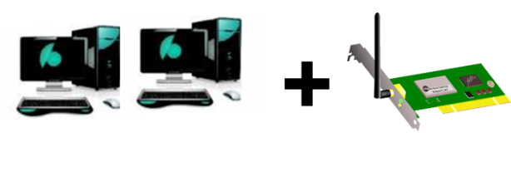**At least two computers** (nodes), each having a **NIC (Network Interface Card** (either wired or wireless)).

The NICs convert the data signals from the nodes into data signals that can be transferred across the network.

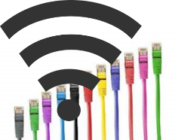**Data Transfer Media:**

* Wires
* Wireless Technology

**A Hub or a Switch**

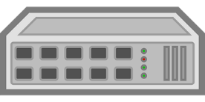A hub is a device that connects nodes together. It makes all connected nodes act as a single segment. It is not considered intelligent as data packets are transmitted across the whole of the network. They are however cheap devices. For example USB hubs are often used in home network installations.

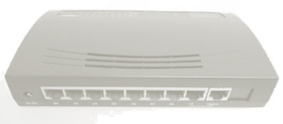A switch is also a device that connects nodes together. It is considered as an intelligent device as it can create and connect to different segments of the network which reduces network traffic because data packets are sent to the nodes or segment where they are needed rather than being broadcast to the whole network.

**A Router**

Although not need to form a LAN, a router is a required if the LAN is to connect to the Internet. Routers manage the data packets enabling them to be sent between networks (e.g. over the internet).

**WAP – Wireless Access Point**

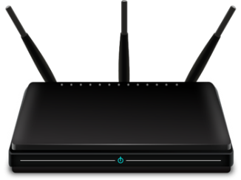If the LAN is to make use of wireless technology if will require a ‘Wireless Access Point’. Wireless technology has many advantages over wired networks:

* There is no need to do building work
* You can add new node with ease
* The general public can access network / internet if allowed.

But there are drawbacks. There can be performance issues as a result of signal interference. There can also be security issues if the data being transferred is not encrypted and is intercepted.

**Types of Network in a Local Area Network**

There are two types of LAN:

* Peer-to-Peer
* Client Server

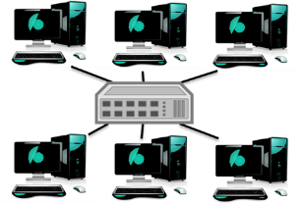In a **peer-to-peer** network, all computers have the same status. Data transfer may be very slow because of data collisions and shared processor power. They are only really suitable for small and low traffic networks and as a result are a very popular design for a home network

In a **client-server** network, at least one computer is designated as a server which is usually required to be a high spec machine due to the jobs it will perform (serving the clients).

A server will offer services such as software and data to client PCs (the client will request a service and the server will serve them). The server will also manage the traffic on the network, record what client users do and provide network security (clients will have to sign in and so their identification is known enabling certain rights to be given to certain people). Large networks may have many servers to handle the increased network demand.

**Network Topologies**

There are several different ways that LANs can be set up and these ‘setups’ are known as topologies. The topology that an organisation will choose will be dependent on the money available, the performance required and the expertise at hand.

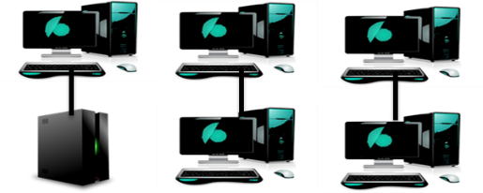***Bus Topology***

In a bus topology there is only one cable which all nodes connect to.

|  |  |
| --- | --- |
| **Advantages** | **Disadvantages** |
| * Cheap to set up due to little cabling requirements. | * Because data travels both ways along one cable, data collides which slows the network. * If the cable has a fault the whole network may suffer. * Only really useful over small areas. |

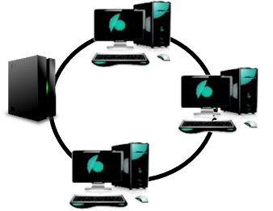

***Ring Topology***

In a ring topology, there is effectively a single cable connecting all nodes, however data travels in one direction, which will mean few data collisions.

|  |  |
| --- | --- |
| **Advantages** | **Disadvantages** |
| * Cheap to set up due to little cabling requirements. * Data travels in only one direction which means fewer data collisions. | * If the cable has a fault the whole network may suffer. |

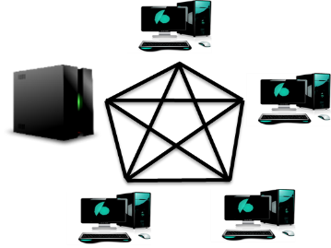

***Mesh Topology***

A mesh topology is a fully connected network as each device is connected to all others, which is good because if a cable has a fault, there will be another route available for data to travel.

|  |  |
| --- | --- |
| **Advantages** | **Disadvantages** |
| * If a cable breaks or if there is heavy traffic in one area, there are other routes for the data to take. | * Can be a very expensive set up due to the cabling required. |

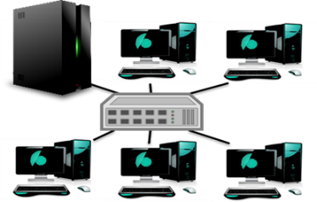***Star Topology***

In a star topology, a hub or a switch will be used to connect all devices, which means that the network performance will be faster due to the increase in cabling – there will be more available routes resulting in fewer data collisions.

|  |  |
| --- | --- |
| **Advantages** | **Disadvantages** |
| * All cables connect to a hub or a switch and therefore data doesn’t share one cable which results in fewer data collisions and therefore a faster network. | * It is the most expensive topology as it requires a lot of cable and addition network devices (hub/switch). |

**Wide Area Networks**

**What is a WAN?**

Wide area networks covers a large geographical area, they could be worldwide. Because of this, devices may be provided by telecoms companies like phone lines and satellites.

**What is the Internet?**

The Internet is the biggest WAN in the world. The internet is a massive network of networks. In other words, it is a ginormous collection of connected computers.

**Is the Internet and the World Wide Web the same?**

Although these two terms are used interchangeably, they are in fact very different. As explained above, the Internet is a ginormous collection of connected computers. The World Wide Web however, is just one application / use of the Internet. The WWW is the web of websites, providing the sharing of information. Other applications of the Internet are E-mail and FTP downloading.

***Keywords / Key Terms:***

Node - A device connected to a network.

Router - A device required to access the internet – it routes data packets to the correct nodes based on the packets address.

Switch - An ‘intelligent’ device which efficiently connects devices on a local area network.