

***STORAGE***

Price (per GB): £0.93

Reliability: ✯✯✯✯✯ (4.5 stars)

Portability: ✯✯✯✯✯

Speed: 225 MB/s

Capacity: 256 GB

**Kingston 256GB Flash Drive**

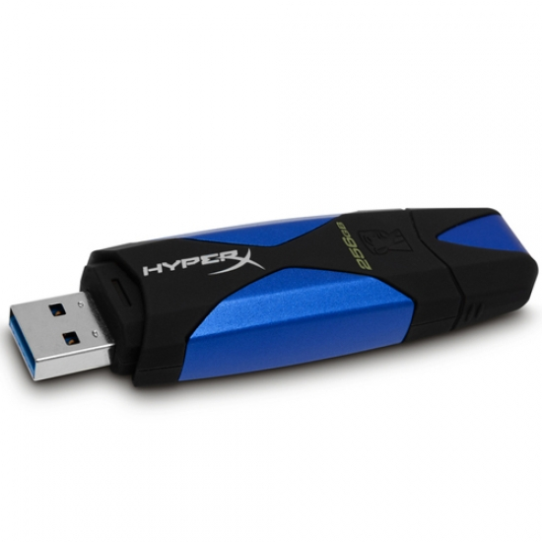

**Stats:**

***STORAGE***

Price (per GB): £0.54

Reliability: ✯✯✯✯✯

Portability: ✯✯✯✯✯

Speed: 1200 KB/s

Capacity: 700 MB

**Sony CD-R**

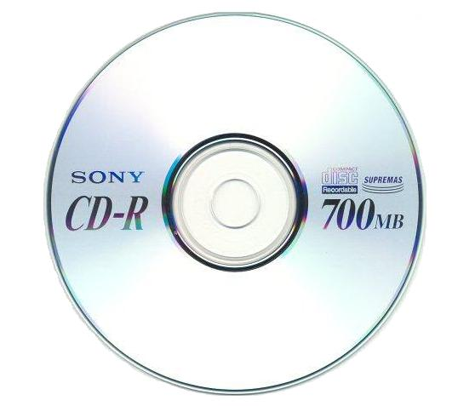

**Stats:**

***STORAGE***

Price (per GB): £0.03

Reliability: ✯✯✯✯✯

Portability: ✯✯✯✯✯

Speed: 120 MB/s

Capacity: 2 TB

**Seagate 2 TB Internal SATA**

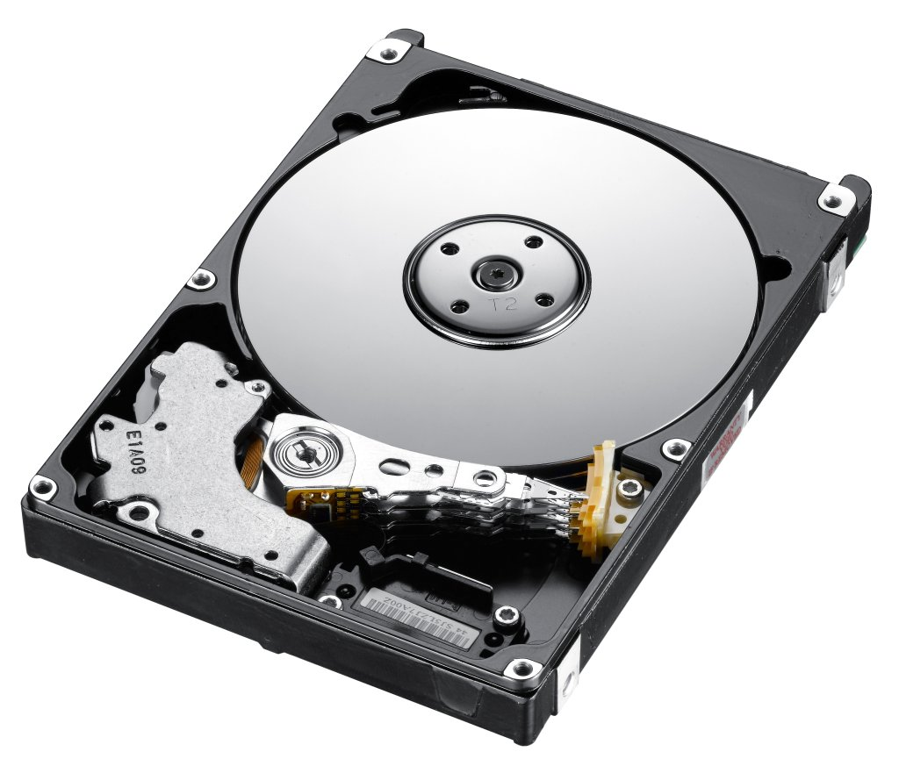

**Stats:**

***STORAGE***

Price (per GB): £0.54

Reliability: ✯✯✯✯✯ (4.5 stars)

Portability: ✯✯✯✯✯

Speed: 30 MB/s

Capacity: 64 GB

**SanDisk 64GB SD Card**

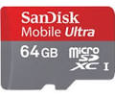

***STORAGE***

**Stats:**



Price (per GB): £0.54

**Stats:**

***STORAGE***

Price (per GB): £0.11

Reliability: ✯✯✯✯✯

Portability: ✯✯✯✯✯

Speed: 33 MB/s

Capacity: 8.5 GB

**Verbatim DVD-R**

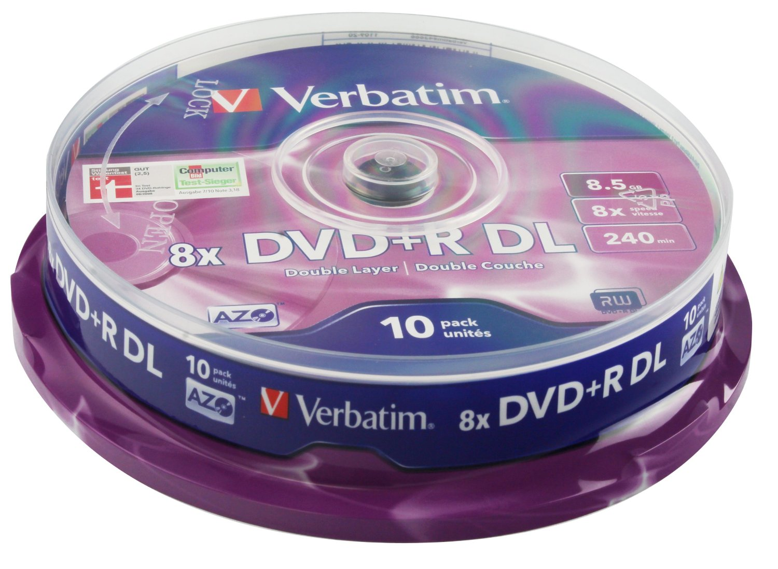

**Stats:**

***STORAGE***

Price (per GB): £0.14

Reliability: ✯✯✯✯✯

Portability: ✯✯✯✯✯

Speed: 72 MB/s

Capacity: 50 GB

**Sony BD-RE Blu-Ray**

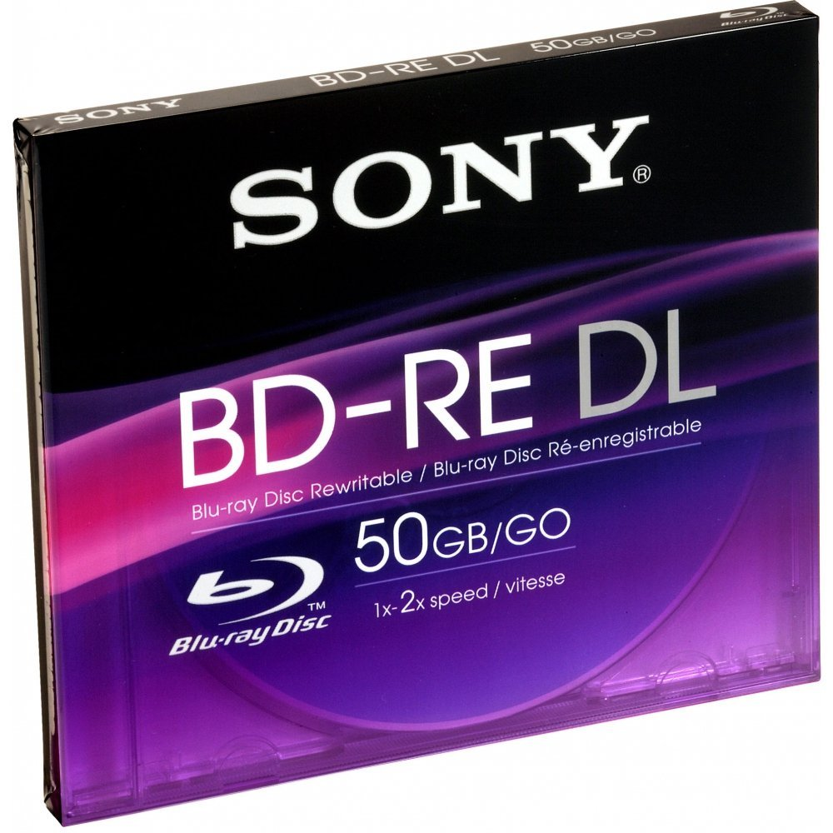

**Samsung M3 Portable HD**

Capacity: 2 TB

Speed: 119 MB/s

Portability: ✯✯✯✯✯

Reliability: ✯✯✯✯✯

Price (per GB): £0.07

***STORAGE***

**Stats:**

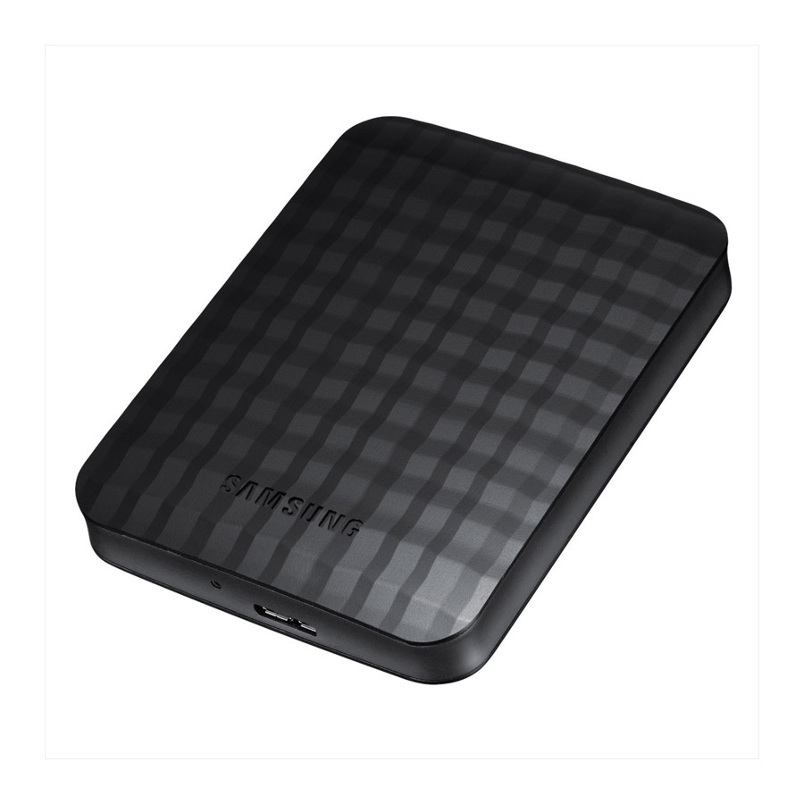

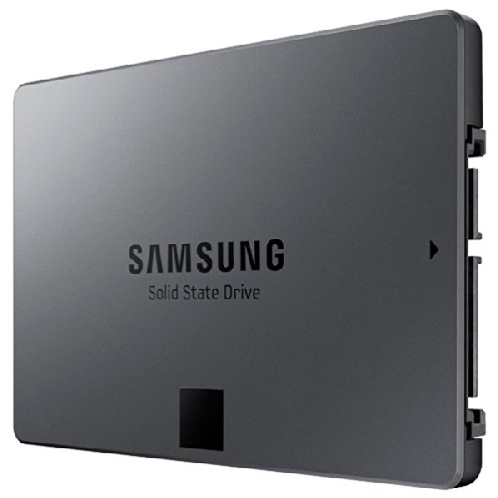

Capacity: 750 GB

Speed: 520 MB/s

Portability: ✯✯✯✯✯

Reliability: ✯✯✯✯✯ (4.5 stars)

**Stats:**

***STORAGE***

**Samsung 840 Solid State Drive**

***STORAGE***