Internet Communications

**Data Packets**

We have already learnt how the Internet is a massive network of networks, but how does data travel around the ginormous network? Data packets are the answer!

When files are sent over the internet they are split into millions of data packets. Packets get sent by different routes according to availability. When you send a file online, the parts of the file might travel one way around the world and the other parts may go in the opposite direction! Packets are reassembled at receiving end.

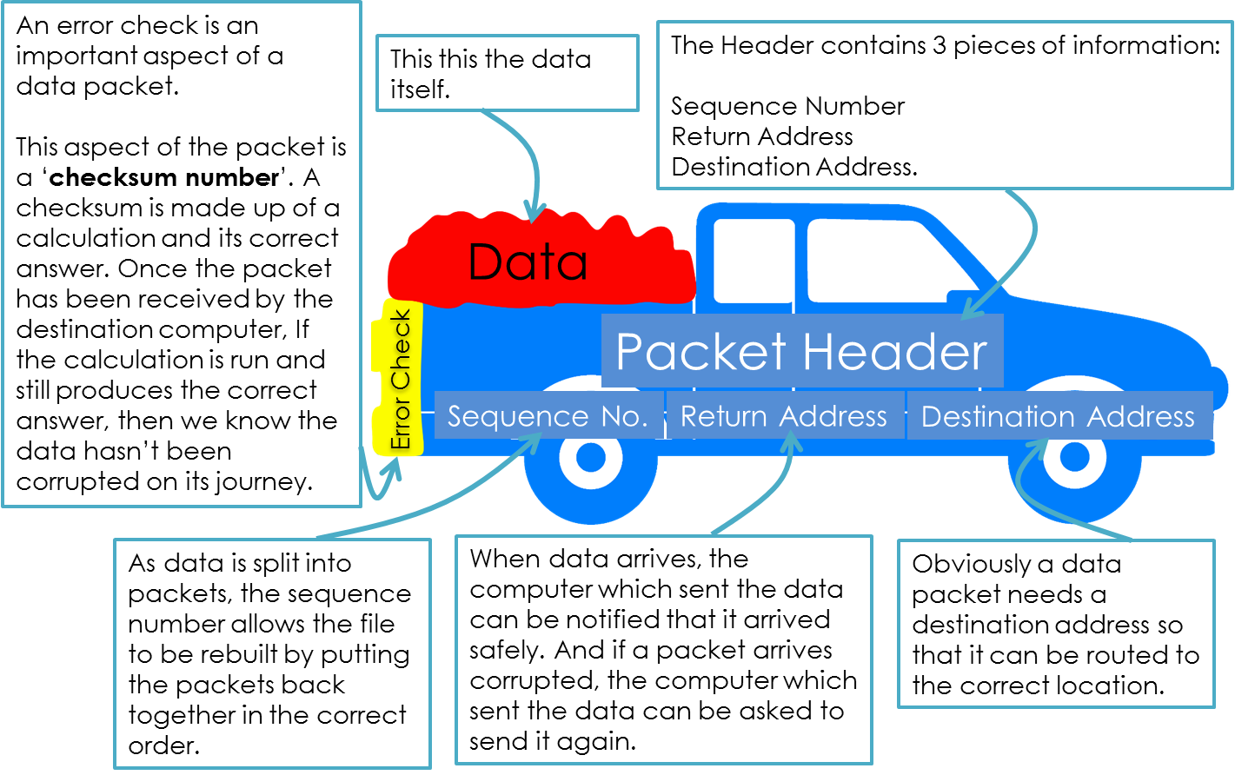Typical packet structure:

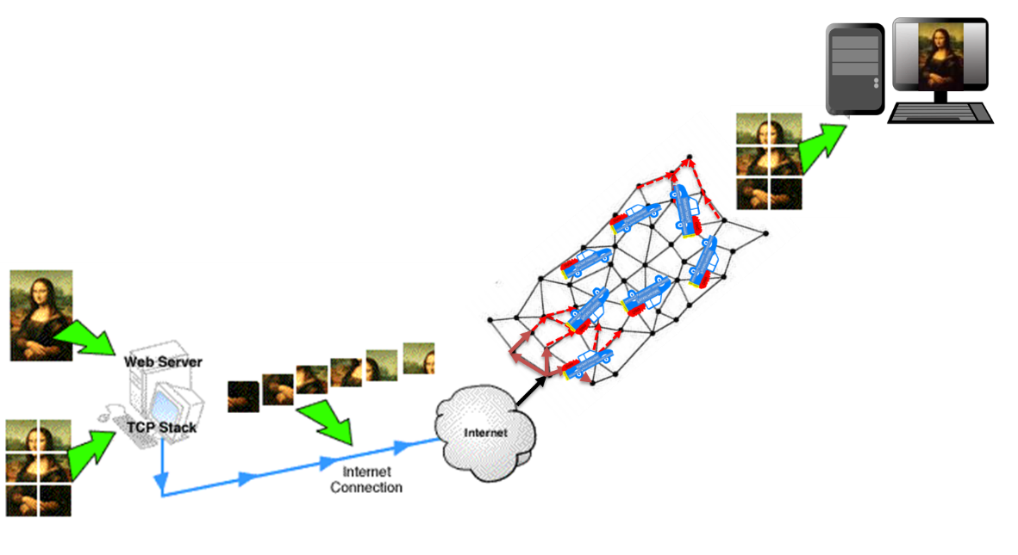

*The amazing way that data is sent across the internet:*

**IP addressing, MAC addressing, and protocols**

So, we have now seen how data is sent around networks in data packets, but because the internet has billions of computers and devices attached to it, these devices will only be able to communicate with one another if they ‘speak the same language’ (i.e. if these data packets are produced and sent in the same standard way). Because of this, the internet is full of protocols, which is really just a fancy name for rules. By manufacturing nodes and network devices to adhere to these rules, all devices on the internet can work effectively. We shall now take a look at some of the major protocols which enables the internet to work. They sound scary but they really are not!

***MAC Addresses***

Just like humans have postal addresses, every network card in the world has a MAC address (MAC - Media Access Control). A MAC address is hard coded into each and every network device and cannot change. It is a 12-digit hexadecimal number (e.g.

56:b3:8f:90:64:ef). It is there so that data being sent over a network can be sent to the correct network card. It is known as a PHYSICAL ADDRESS

***IP Addresses***

Just like each network card will have a MAC address, every computer on a network will have an IP address. They are usually a 32bit number written as 4 decimal numbers (e.g.:

129.168.1.101). They are required for the same reason…so that data being sent over a network can be sent to the correct node. The main difference is that an IP address is not hard coded into the computer. It can change and is therefore said to be dynamic. The reason for this is so that on a network, similar types of hardware can be grouped by being assigned similar IP addresses. For example, computers could all be given an IP address starting 190, printers could be given an IP address staring 200 and so on. This means that different types of device can be more easily managed on a network.

**The TCP/IP Protocol**

This is probably the most important protocol as it determines how all data is sent over the internet. Actually it is made up of two protocols:

*TCP – Transmission Control Protocol*

We saw earlier how data is split into packets before being sent across the internet. The TCP defines the rules for this.

* It ensures all data is split up into data packets in the same way.
* It ensures that these data packets are put back together when received by the destination device.
* It also ensures that any data received is the same as that sent.

*IP – Internet Protocol*

This rule is in place to ensure that data packets are directed towards their destination in the most appropriate way (which may not be the shortest way).

This is called ‘Packet Switching’ and we will now look at this in more detail.

*Packet Switching*

TCP/IP – Transmission Control Protocol / Internet Protocol

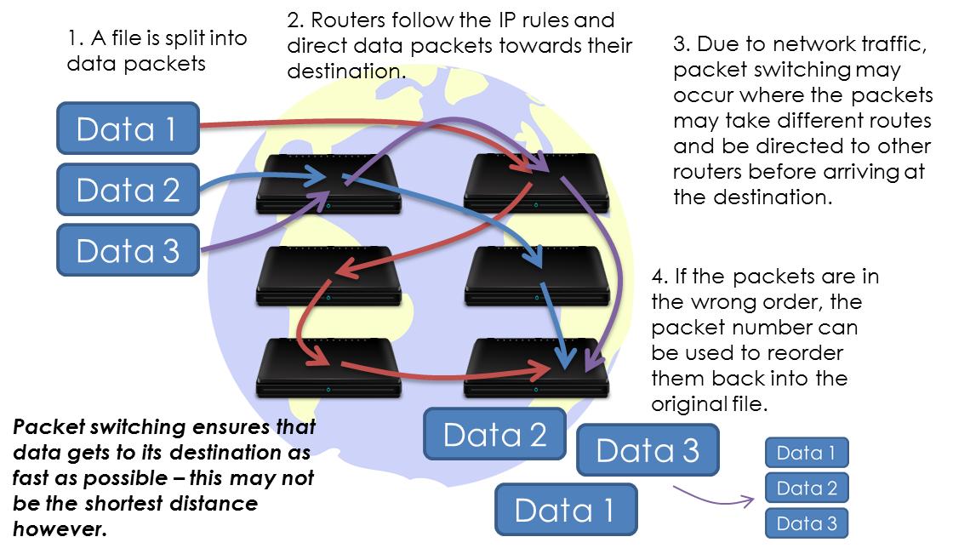

**Circuit Switching – an alternative to packet switching**

Packet switching is a great way of enabling two or more devices to connect on communication lines that are shared by a vast number of other devices.

As the internet consists of a network of communication channels that are shared by millions of users, it is in fact the only efficient way that data can be sent to the right users on a shared line.

Circuit switching is another way to connect two devices, but this method is actually inferior (when compared to packet switching) in many ways.

Circuit switching is when two devices are connected together on a dedicated communication channel. This is the case when people phone one another. The switchboard route calls from one person to another. This does bring the advantage of the data being sent in order meaning that there is no delay in receiving the data (voice call). However, this massively wastes bandwidth as others cannot use the same communication channels. Furthermore, it can only be used by two devices which send and receive data at the same rate.

Nevertheless, circuit witching is another way that data can be sent from one device to the other, even if it is a less efficient in certain ways.

**World Wide Web (website) Protocols**

*HTTP – Hyper Text Transfer Protocol*

This is the protocol which governs the way in which websites and web servers are accessed by web browsers. By conforming to the same standards it means that all browsers can access all websites on the WWW.

*HTTPS – Hyper Text Transfer Protocol (SECURE)*

This protocol is almost identical to HTTP. The only difference is that it ensures all data being sent is encrypted and so makes web data communication far more secure.

**File Transfer (Upload, Download, Read and Write) Protocols**

FTP – File Transfer Protocol

If you have your documents / files stored on a file server, the way you access them will be governed by the File Transfer Protocol. This standard (FTP) ensure that all clients (computers) on a network can access files from a server in the same way.

**Email Protocols**

*POP – Post Office Protocol*

This is the protocol which governs how emails are accessed from a server. Email clients will use this protocol to access emails from a server in the same way.

*IMAP – Internet Message Access Protocol*

This is similar to POP but with one important difference. With IMAP, the email will remain on the server once it has been downloaded by a mail client. This allows other devices to also access the emails which is important for users with multiple devices – they can synchronise their emails across all devices.

*SMTP – Simple Mail Transfer Protocol*

This protocol governs how data is sent between mail servers. By conforming to the same standards, emails can be sent to and from all mail servers across the internet.

**The Layers of a Network**

All of these protocols which enable the internet to function correctly can be divided into ‘Layers of the Internet’. Each layer has similar functions and each layer provides a base for the layer above it – in other words, each layer does all the hard work for the layer above it!

|  |  |  |
| --- | --- | --- |
| Layer | Example Protocols | Layer Purpose |
| Application Layer – Layer 4 | FTP, HTTP, SMTP | Provides user access to applications websites, files, email. |
| Transport Layer – Layer 3 | TCP | Provides transport of data between devices by splitting files into data packets and checking that they have been sent and received correctly. |
| Network Layer – Layer 2 | IP | Provides the routing of data across the network by making use of addressing. |
| Data Link Layer & Physical Layer – Layer 1 | Ethernet | Provides the physical transport of data through electrical signals etc. |

For example, if you are accessing a website (HTTP - layer 4), it requires data to be split into packets and sent across the internet (TCP – layer 3 / IP – layer 2), which in turns requires the physical transport of data via cables (cables / Wi-Fi – layer 1).

**Physical Vs Logical Protocols**

The protocols that govern the internet can be grouped into two categories: Physical & Logical.

Physical protocols are rules which govern the physical mediums through which the data is travelling which might be via cables or using wireless technology.

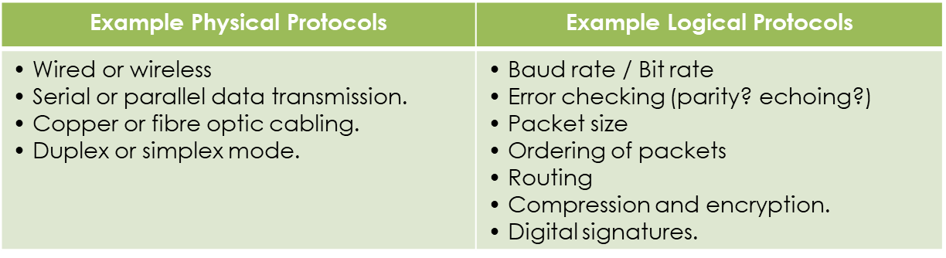Logical protocols are rules which govern the data being sent, for example, packet size or routing.

**Handshaking**

When two devices communicate over the internet they need to decide on certain protocols and this process is known as handshaking. It is simply carried out by one device sending a list of protocols to use, to another device and receiving an acknowledgement back in return. If the devices fail to agree with the choice of protocols, another set must be chosen or they will fail to communicate.

***Keywords / Key Terms:***

**Protocol -** Another name for a rule. In terms of networks, they are rules which govern how networks work.

**Data Packet -** A fragment of a file enabling data to be sent across a network / the internet.