Gotcha database helpsheet
Your task is to use the database of suspects compiled by the Grunge Hill Constabulary to help you identify a likely culprit for a particular crime. Sample entries from this database are shown below:

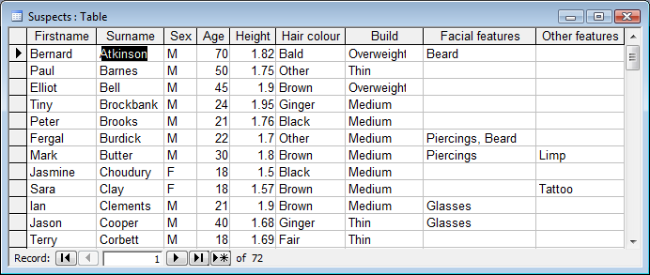

There are 9 different fields in the Suspects table. When you are searching for a particular characteristic, you must be careful to spell correctly – e.g. “tattoo” not “tatoo”, “Piercings” not “Pearcings”.

Field name | Valid entries  Sample clues:  “Approximately 1.8 metres tall”  “Initials T.C.”  “He was just a teenager”  “She had long blonde hair”  “She wasn’t overweight”  “He had a ring through his lip”
Firstname | Bernard, Paul etc.
Surname | Bell, Clay etc
Sex | M or F
Age | 18, 35, 67 etc
Height | 1.5, 1.72 etc
Hair colour | Black, Brown, Fair, Ginger, Bald, Other
Build | Slim, Thin, Medium, Overweight
Facial Features | Beard, Moustache, Piercings, Glasses
Other features | Limp, Tattoo

Using query operators
Operator | Meaning | Example
< | Less than | <1.65
<= | Less than or equal to | <=40
> | Greater than | >1.9
>= | Greater than or equal to | >=30
= | Equal to | =”M”
BETWEEN | Tests for a range of values | BETWEEN 18 AND 25
AND | All criteria must be satisfied
OR | At least one of the criteria must be satisfied | “medium” OR “overweight”
NOT | All criteria are satisfied except for the ones specified | NOT “bald” AND NOT “fair”

You can also use a wildcard, *. The criterion Firstname = “B*” will find all those whose first name begins with B. Other Features = *T*” will find, for example, Tattoo, Limp or Tattoo

